|  |  |  |  |  |  |  |  |  |  |  |  |  |  |  |  |  |  |  |  |  |  |  |  |  |
| --- | --- | --- | --- | --- | --- | --- | --- | --- | --- | --- | --- | --- | --- | --- | --- | --- | --- | --- | --- | --- | --- | --- | --- | --- |
| *#EX.NO :1.a Basic Practice Experiments(1 to 4)*  *#DATA : 30.07.2024*  *#NAME : Vishvaa.J*  *#ROLL NO : 230701509*  *#DEPARTMENT : B.E COMPUTER SCIENCE AND ENGINEERING .SECTION- D*  import pandas as pd import numpy as np import seaborn as sns  import matplotlib.pyplot as plt  %matplotlib inline  data=pd.read_csv('Iris.csv') data   |  |  |  |  | | --- | --- | --- | --- | | Id SepalLengthCm SepalWidthCm PetalLengthCm PetalWidthCm \ | | | | | 1. 1 5.1 3.5 1.4 0.2 2. 2 4.9 3.0 1.4 0.2 3. 3 4.7 3.2 1.3 0.2 4. 4 4.6 3.1 1.5 0.2 5. 5 5.0 3.6 1.4 0.2.. ... ... ... ... ... 6. 146 6.7 3.0 5.2 2.3 7. 147 6.3 2.5 5.0 1.9 8. 148 6.5 3.0 5.2 2.0 9. 149 6.2 3.4 5.4 2.3 10. 150 5.9 3.0 5.1 1.8 | | |  | | Species   1. Iris-setosa 2. Iris-setosa 3. Iris-setosa 4. Iris-setosa 5. Iris-setosa .. ... 6. Iris-virginica 7. Iris-virginica 8. Iris-virginica 9. Iris-virginica 10. Iris-virginica | | [150 rows x 6 columns] | |   data.info()   |  |  |  |  | | --- | --- | --- | --- | | <class 'pandas.core.frame.DataFrame'> | | |  | | RangeIndex: 150 entries, 0 to 149 | |  | | Data columns (total 6 columns): |  | | # Column Non-Null Count Dtype  --- ------ -------------- ----- | | | | |

1. Id 150 non-null int64
2. SepalLengthCm 150 non-null float64
3. SepalWidthCm 150 non-null float64
4. PetalLengthCm 150 non-null float64
5. PetalWidthCm 150 non-null float64 5 Species 150 non-null object dtypes: float64(4), int64(1), object(1) memory usage: 7.2+ KB data.describe()

Id SepalLengthCm SepalWidthCm PetalLengthCm

PetalWidthCm

count 150.000000 150.000000 150.000000 150.000000

150.000000

mean 75.500000 5.843333 3.054000 3.758667

1.198667

std 43.445368 0.828066 0.433594 1.764420

0.763161

min 1.000000 4.300000 2.000000 1.000000

0.100000

25% 38.250000 5.100000 2.800000 1.600000

0.300000

50% 75.500000 5.800000 3.000000 4.350000

1.300000

75% 112.750000 6.400000 3.300000 5.100000

1.800000

max 150.000000 7.900000 4.400000 6.900000 2.500000

data.value_counts('Species')

Species

Iris-setosa 50

Iris-versicolor 50

Iris-virginica 50

Name: count, dtype: int64

sns.countplot(x='Species',data=data,) plt.show()

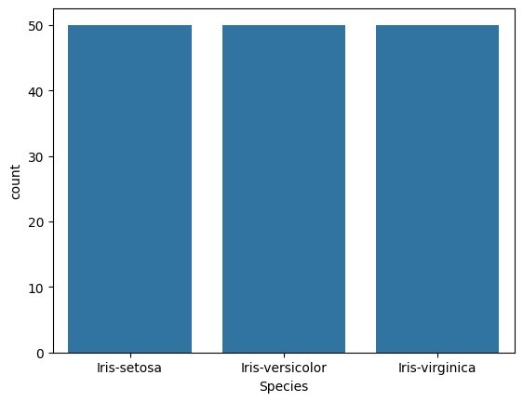

|  |  |  |  |  |  |  |  |
| --- | --- | --- | --- | --- | --- | --- | --- |
| dummies=pd.get_dummies(data.Species)  FinalDataset=pd.concat([pd.get_dummies(data.Species),data.iloc[:, [0,1,2,3]]],axis=1) FinalDataset.head()   |  |  |  | | --- | --- | --- | | Iris-setosa Iris-versicolor Iris-virginica Id SepalLengthCm \ | | | | 1. True False False 1 5.1 2. True False False 2 4.9 3. True False False 3 4.7 4. True False False 4 4.6 5. True False False 5 5.0 | |  | | SepalWidthCm PetalLengthCm   1. 3.5 1.4 2. 3.0 1.4 3. 3.2 1.3 4. 3.1 1.5 5. 3.6 1.4 |   sns.scatterplot(x='SepalLengthCm',y='SepalWidthCm',hue='Species',data= data,)  <Axes: xlabel='SepalLengthCm', ylabel='SepalWidthCm'> |

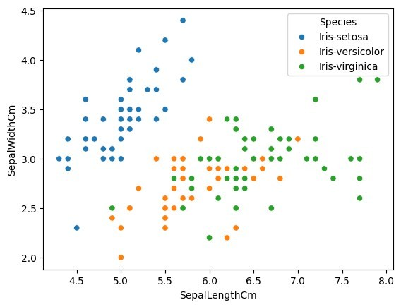

sns.scatterplot(x='PetalLengthCm',y='PetalWidthCm',hue='Species',data= data,)

<Axes: xlabel='PetalLengthCm', ylabel='PetalWidthCm'>

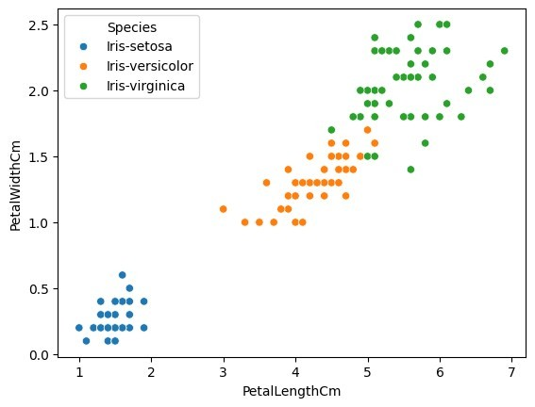

sns.pairplot(data,hue='Species',height=3);

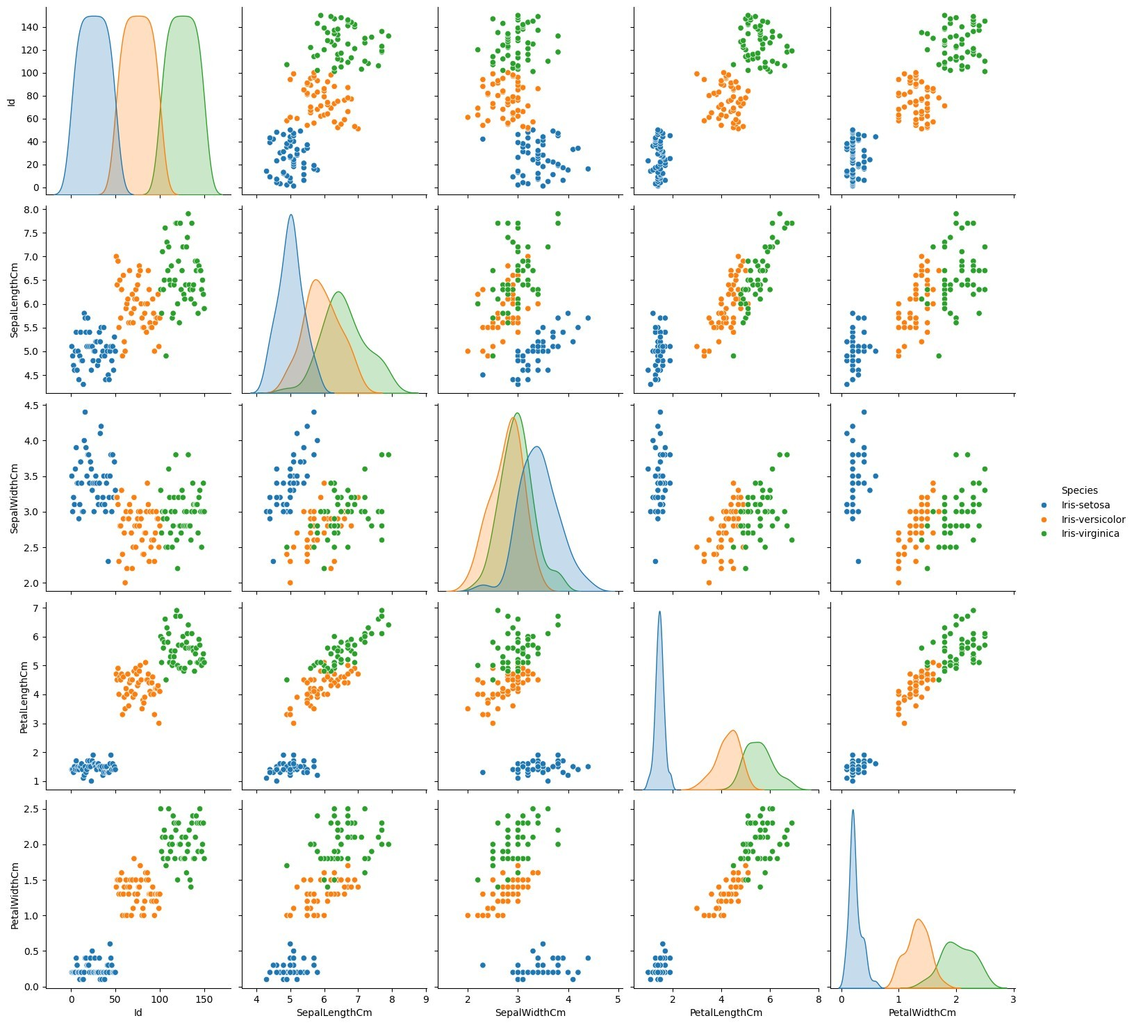

plt.show()

sns.FacetGrid(data,hue='Species',height=5).map(sns.histplot,'PetalLeng thCm').add_legend(); plt.show();

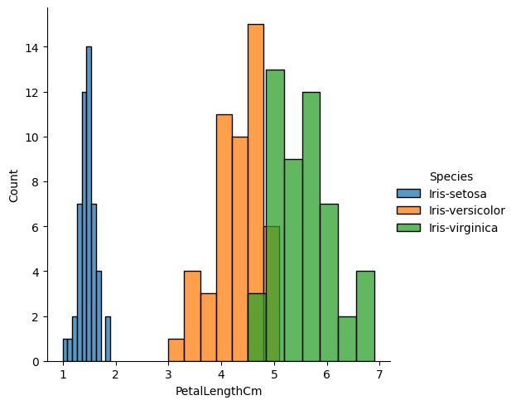

sns.FacetGrid(data,hue='Species',height=5).map(sns.histplot,'PetalWidt hCm').add_legend(); plt.show();

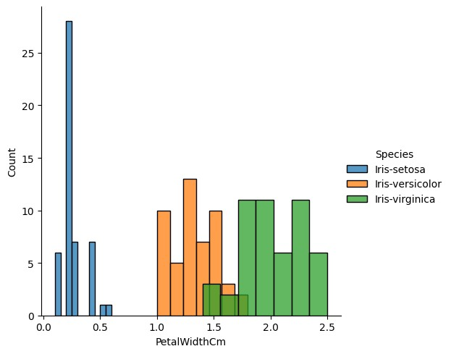

sns.FacetGrid(data,hue='Species',height=5).map(sns.histplot,'SepalLeng thCm').add_legend(); plt.show();

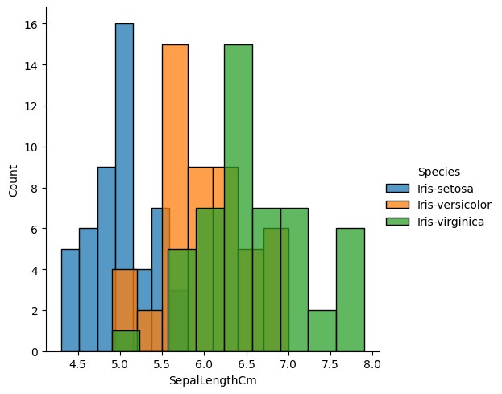

sns.FacetGrid(data,hue='Species',height=5).map(sns.histplot,'SepalWidt hCm').add_legend(); plt.show();

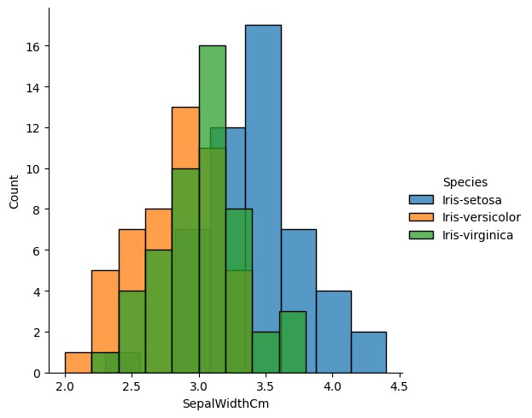

|  |  |  |  |  |  |
| --- | --- | --- | --- | --- | --- |
| *#EX.NO :1.b Pandas Buit in function. Numpy Buit in fuction- Array*  *slicing, Ravel,Reshape,ndim #DATA : 06.08.2024*  *#NAME : VISHVAA.J*  *#ROLL NO : 230701509*  *#DEPARTMENT : B.E COMPUTER SCIENCE AND ENGINEERING – SECTION-D*  import numpy as np  array=np.random.randint(1,100,9) array   |  | | --- | | array([39, 97, 88, 58, 29, 87, 27, 88, 91]) |   np.sqrt(array)   |  |  | | --- | --- | | array([6.244998 , 9.8488578 , 9.38083152, 7.61577311, 5.38516481, | | | 9.32737905, 5.19615242, 9.38083152, 9.53939201]) |  |   array.ndim |

|  |  |  |  |  |
| --- | --- | --- | --- | --- |
| 1  new_array=array.reshape(3,3) new_array  array([[39, 97, 88], [58, 29, 87],  [27, 88, 91]]) new_array.ndim 2  new_array.ravel()   |  | | --- | | array([39, 97, 88, 58, 29, 87, 27, 88, 91]) |   newm=new_array.reshape(3,3) newm  array([[39, 97, 88], [58, 29, 87],  [27, 88, 91]]) newm[2,1:3]   |  | | --- | | array([88, 91]) |   newm[1:2,1:3]   |  | | --- | | array([[29, 87]]) |   new_array[0:3,0:0]   |  | | --- | | array([], shape=(3, 0), dtype=int32) |   new_array[1:3]  array([[58, 29, 87], [27, 88, 91]])  *#EX.NO :2 Outlier detection*  *#DATA : 13.08.2024*  *#NAME : VISHVAA.J*  *#ROLL NO : 230701509*  *#DEPARTMENT : B.E COMPUTER SCIENCE AND ENGINEERING – SECTION-D*  import numpy as np import warnings  warnings.filterwarnings('ignore') |

|  |  |  |  |  |  |  |  |  |  |  |
| --- | --- | --- | --- | --- | --- | --- | --- | --- | --- | --- |
| array=np.random.randint(1,100,16) array   |  |  | | --- | --- | | array([37, 15, 49, 89, 30, 47, 2, 86, 53, 63, 41, 46, 42, 27, 5, | | | 97]) |  |   array.mean()   |  | | --- | | 45.5625 |   np.percentile(array,25)   |  | | --- | | 29.25 |   np.percentile(array,50)   |  | | --- | | 44.0 |   np.percentile(array,75)   |  | | --- | | 55.5 |   np.percentile(array,100)   |  | | --- | | 97.0 |   *#outliers detection* def outDetection(array): sorted(array)  Q1,Q3=np.percentile(array,[25,75]) IQR=Q3-Q1 lr=Q1-(1.5*IQR) ur=Q3+(1.5*IQR) return lr,ur lr,ur=outDetection(array) lr,ur   |  | | --- | | (-10.125, 94.875) |   import seaborn as sns %matplotlib inline sns.displot(array)  <seaborn.axisgrid.FacetGrid at 0x20d7cda3b50> |

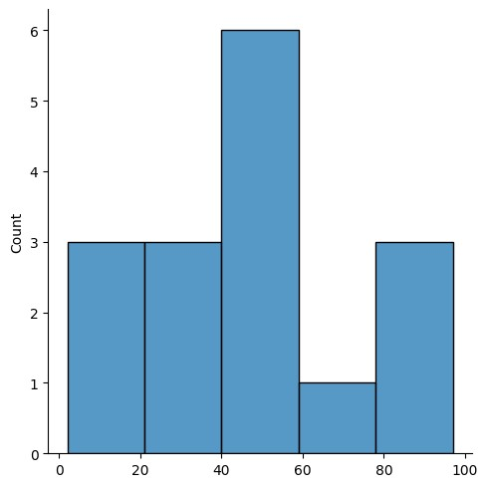

sns.distplot(array) <Axes: ylabel='Density'>

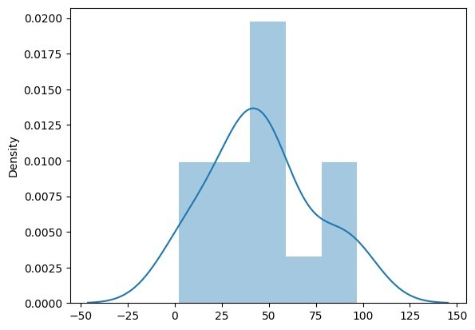

|  |  |
| --- | --- |
| new_array=array[(array>lr) & (array<ur)] new_array   |  | | --- | | array([37, 15, 49, 89, 30, 47, 2, 86, 53, 63, 41, 46, 42, 27, 5]) |   sns.displot(new_array)  <seaborn.axisgrid.FacetGrid at 0x20d7d02d950> |

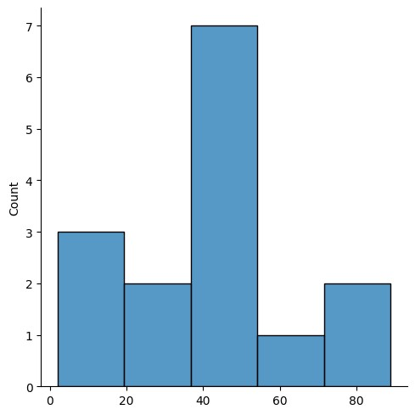

|  |  |  |
| --- | --- | --- |
| lr1,ur1=outDetection(new_array) lr1,ur1   |  | | --- | | (-5.25, 84.75) |   final_array=new_array[(new_array>lr1) & (new_array<ur1)] final_array   |  | | --- | | array([37, 15, 49, 30, 47, 2, 53, 63, 41, 46, 42, 27, 5]) |   sns.distplot(final_array) <Axes: ylabel='Density'> |

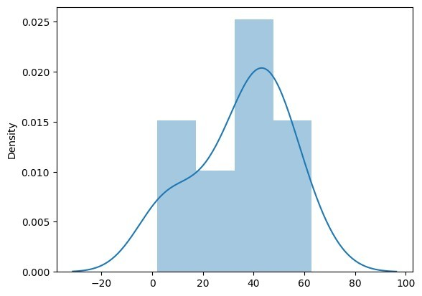

|  |  |  |  |
| --- | --- | --- | --- |
| *#EX.NO :3 Missing and inappropriate data*  *#DATA : 20.08.2024*  *#NAME : VISHVAA.J*  *#ROLL NO : 230701509*  *#DEPARTMENT : B.E COMPUTER SCIENCE AND ENGINEERING – SECTION-D*  import numpy as np import pandas as pd import warnings  warnings.filterwarnings('ignore') df=pd.read_csv("Hotel_Dataset.csv") df     |  | | --- | | CustomerID Age_Group Rating(1-5) Hotel FoodPreference Bill | |  | | 1 20-25 4 Ibis veg 1300 |   \  0   1. 2 30-35 5 LemonTree Non-Veg 2000 2. 3 25-30 6 RedFox Veg 1322 3. 4 20-25 -1 LemonTree Veg 1234 4. 5 35+ 3 Ibis Vegetarian 989 |

|  |  |  |
| --- | --- | --- |
| 1. 6 35+ 3 Ibys Non-Veg 1909 2. 7 35+ 4 RedFox Vegetarian 1000 3. 8 20-25 7 LemonTree Veg 2999 4. 9 25-30 2 Ibis Non-Veg 3456 5. 9 25-30 2 Ibis Non-Veg 3456 10 10 30-35 5 RedFox non-Veg -6755  |  | | --- | | NoOfPax EstimatedSalary Age_Group.1   1. 2 40000 20-25 2. 3 59000 30-35 3. 2 30000 25-30 4. 2 120000 20-25 5. 2 45000 35+ 6. 2 122220 35+ 7. -1 21122 35+ 8. -10 345673 20-25 9. 3 -99999 25-30 10. 3 -99999 25-30 11. 4 87777 30-35 |   df.duplicated()   |  | | --- | | 1. False 2. False 3. False 4. False 5. False 6. False 7. False 8. False 9. False 10. True 10 False dtype: bool |   df.info()  <class 'pandas.core.frame.DataFrame'>  RangeIndex: 11 entries, 0 to 10 Data columns (total 9 columns):  # Column Non-Null Count Dtype  --- ------ -------------- -----   1. CustomerID 11 non-null int64 2. Age_Group 11 non-null object 3. Rating(1-5) 11 non-null int64 |

|  |  |  |  |  |
| --- | --- | --- | --- | --- |
| 1. Hotel 11 non-null object 2. FoodPreference 11 non-null object 3. Bill 11 non-null int64 4. NoOfPax 11 non-null int64 5. EstimatedSalary 11 non-null int64 8 Age_Group.1 11 non-null object   dtypes: int64(5), object(4) memory usage: 924.0+ bytes  df.drop_duplicates(inplace=True) df     |  | | --- | | CustomerID Age_Group Rating(1-5) Hotel FoodPreference Bill | |  | | 1 20-25 4 Ibis veg 1300 |   \  0   1. 2 30-35 5 LemonTree Non-Veg 2000 2. 3 25-30 6 RedFox Veg 1322 3. 4 20-25 -1 LemonTree Veg 1234 4. 5 35+ 3 Ibis Vegetarian 989 5. 6 35+ 3 Ibys Non-Veg 1909 6. 7 35+ 4 RedFox Vegetarian 1000 7. 8 20-25 7 LemonTree Veg 2999 8. 9 25-30 2 Ibis Non-Veg 3456 10 10 30-35 5 RedFox non-Veg -6755  |  | | --- | | NoOfPax EstimatedSalary Age_Group.1   1. 2 40000 20-25 2. 3 59000 30-35 3. 2 30000 25-30 4. 2 120000 20-25 5. 2 45000 35+ 6. 2 122220 35+ 7. -1 21122 35+ 8. -10 345673 20-25 9. 3 -99999 25-30   10 4 87777 30-35 |   len(df)  10 |

index=np.array(list(range(0,len(df)))) df.set_index(index,inplace=True) index

array([0, 1, 2, 3, 4, 5, 6, 7, 8, 9]) df

CustomerID Age_Group Rating(1-5) Hotel FoodPreference Bill

NoOfPax \

1. 1 20-25 4 Ibis veg 1300

2

1. 2 30-35 5 LemonTree Non-Veg 2000

3

1. 3 25-30 6 RedFox Veg 1322

2

1. 4 20-25 -1 LemonTree Veg 1234

2

1. 5 35+ 3 Ibis Vegetarian 989

2

1. 6 35+ 3 Ibys Non-Veg 1909

2

1. 7 35+ 4 RedFox Vegetarian 1000

-1

1. 8 20-25 7 LemonTree Veg 2999

-10

1. 9 25-30 2 Ibis Non-Veg 3456

3

1. 10 30-35 5 RedFox non-Veg -6755

4

EstimatedSalary Age_Group.1

1. 40000 20-25
2. 59000 30-35
3. 30000 25-30
4. 120000 20-25
5. 45000 35+
6. 122220 35+
7. 21122 35+
8. 345673 20-25
9. -99999 25-30 9 87777 30-35

df.drop(['Age_Group.1'],axis=1,inplace=True) df

CustomerID Age_Group Rating(1-5) Hotel FoodPreference Bill

NoOfPax \

1. 1 20-25 4 Ibis veg 1300 2
2. 2 30-35 5 LemonTree Non-Veg 2000

3

1. 3 25-30 6 RedFox Veg 1322

2

1. 4 20-25 -1 LemonTree Veg 1234

2

1. 5 35+ 3 Ibis Vegetarian 989

2

1. 6 35+ 3 Ibys Non-Veg 1909

2

1. 7 35+ 4 RedFox Vegetarian 1000

-1

1. 8 20-25 7 LemonTree Veg 2999

-10

1. 9 25-30 2 Ibis Non-Veg 3456

3

1. 10 30-35 5 RedFox non-Veg -6755

4

EstimatedSalary

1. 40000
2. 59000
3. 30000
4. 120000
5. 45000
6. 122220
7. 21122
8. 345673
9. -99999 9 87777

df.CustomerID.loc[df.CustomerID<0]=np.nan df.Bill.loc[df.Bill<0]=np.nan

df.EstimatedSalary.loc[df.EstimatedSalary<0]=np.nan df

CustomerID Age_Group Rating(1-5) Hotel FoodPreference Bill

\

1. 1.0 20-25 4 Ibis veg 1300.0
2. 2.0 30-35 5 LemonTree Non-Veg 2000.0
3. 3.0 25-30 6 RedFox Veg 1322.0
4. 4.0 20-25 -1 LemonTree Veg 1234.0
5. 5.0 35+ 3 Ibis Vegetarian 989.0
6. 6.0 35+ 3 Ibys Non-Veg 1909.0

|  |  |  |  |  |  |
| --- | --- | --- | --- | --- | --- |
| 1. 7.0 35+ 4 RedFox Vegetarian 1000.0 2. 8.0 20-25 7 LemonTree Veg 2999.0 3. 9.0 25-30 2 Ibis Non-Veg 3456.0 9 10.0 30-35 5 RedFox non-Veg NaN  |  | | --- | | NoOfPax EstimatedSalary   1. 2 40000.0 2. 3 59000.0 3. 2 30000.0 4. 2 120000.0 5. 2 45000.0 6. 2 122220.0 7. -1 21122.0 8. -10 345673.0 9. 3 NaN 10. 4 87777.0 |   df['NoOfPax'].loc[(df['NoOfPax']<1) | (df['NoOfPax']>20)]=np.nan df     |  | | --- | | CustomerID Age_Group Rating(1-5) Hotel FoodPreference Bill | |  | | 1.0 20-25 4 Ibis veg 1300.0 |   \  0   1. 2.0 30-35 5 LemonTree Non-Veg 2000.0 2. 3.0 25-30 6 RedFox Veg 1322.0 3. 4.0 20-25 -1 LemonTree Veg 1234.0 4. 5.0 35+ 3 Ibis Vegetarian 989.0 5. 6.0 35+ 3 Ibys Non-Veg 1909.0 6. 7.0 35+ 4 RedFox Vegetarian 1000.0 7. 8.0 20-25 7 LemonTree Veg 2999.0 8. 9.0 25-30 2 Ibis Non-Veg 3456.0 9. 10.0 30-35 5 RedFox non-Veg NaN  |  | | --- | | NoOfPax EstimatedSalary   1. 2.0 40000.0 2. 3.0 59000.0 3. 2.0 30000.0 | |

|  |  |  |  |  |  |  |  |  |  |  |  |  |  |  |  |
| --- | --- | --- | --- | --- | --- | --- | --- | --- | --- | --- | --- | --- | --- | --- | --- |
| |  | | --- | | 1. 2.0 120000.0 2. 2.0 45000.0 3. 2.0 122220.0 4. NaN 21122.0 5. NaN 345673.0 6. 3.0 NaN 7. 4.0 87777.0 |   df.Age_Group.unique()   |  | | --- | | array(['20-25', '30-35', '25-30', '35+'], dtype=object) |   df.Hotel.unique()   |  | | --- | | array(['Ibis', 'LemonTree', 'RedFox', 'Ibys'], dtype=object) |   df.Hotel.replace(['Ibys'],'Ibis',inplace=True) df.FoodPreference.unique   |  |  |  | | --- | --- | --- | | <bound method Series.unique of 0 veg | | | | 1. Non-Veg 2. Veg 3. Veg 4. Vegetarian 5. Non-Veg 6. Vegetarian 7. Veg 8. Non-Veg 9. non-Veg |  | | | Name: FoodPreference, dtype: object> | |  |   df.FoodPreference.replace(['Vegetarian','veg'],'Veg',inplace=True) df.FoodPreference.replace(['non-Veg'],'Non-Veg',inplace=True)  df.EstimatedSalary.fillna(round(df.EstimatedSalary.mean()),inplace=Tru e)  df.NoOfPax.fillna(round(df.NoOfPax.median()),inplace=True) df['Rating(1-5)'].fillna(round(df['Rating(1-5)'].median()), inplace=True)  df.Bill.fillna(round(df.Bill.mean()),inplace=True) df     |  | | --- | | CustomerID Age_Group Rating(1-5) Hotel FoodPreference Bill | |  | | 1.0 20-25 4 Ibis Veg 1300.0 |   \  0   1. 2.0 30-35 5 LemonTree Non-Veg 2000.0 2. 3.0 25-30 6 RedFox Veg 1322.0 3. 4.0 20-25 -1 LemonTree Veg 1234.0 |

|  |  |  |
| --- | --- | --- |
| 1. 5.0 35+ 3 Ibis Veg 989.0 2. 6.0 35+ 3 Ibis Non-Veg 1909.0 3. 7.0 35+ 4 RedFox Veg 1000.0 4. 8.0 20-25 7 LemonTree Veg 2999.0 5. 9.0 25-30 2 Ibis Non-Veg 3456.0 9 10.0 30-35 5 RedFox Non-Veg 1801.0  |  | | --- | | NoOfPax EstimatedSalary   1. 2.0 40000.0 2. 3.0 59000.0 3. 2.0 30000.0 4. 2.0 120000.0 5. 2.0 45000.0 6. 2.0 122220.0 7. 2.0 21122.0 8. 2.0 345673.0 9. 3.0 96755.0 10. 4.0 87777.0 |   *#EX.NO :4 Data Preprocessing*  *#DATA : 27.08.2024*  *#NAME : VISHVAA.J*  *#ROLL NO : 230701509*  *#DEPARTMENT : B.E COMPUTER SCIENCE AND ENGINEERING – SECTION-D*  import numpy as np import pandas as pd import warnings  warnings.filterwarnings('ignore')  df=pd.read_csv("pre_process_datasample.csv") df   |  | | --- | | Country Age Salary Purchased   1. France 44.0 72000.0 No 2. Spain 27.0 48000.0 Yes 3. Germany 30.0 54000.0 No 4. Spain 38.0 61000.0 No 5. Germany 40.0 NaN Yes 6. France 35.0 58000.0 Yes 7. Spain NaN 52000.0 No 8. France 48.0 79000.0 Yes 9. Germany 50.0 83000.0 No 10. France 37.0 67000.0 Yes | |

|  |  |  |  |  |  |  |  |  |
| --- | --- | --- | --- | --- | --- | --- | --- | --- |
| df.info()  <class 'pandas.core.frame.DataFrame'>  RangeIndex: 10 entries, 0 to 9 Data columns (total 4 columns):  # Column Non-Null Count Dtype  --- ------ -------------- -----   1. Country 10 non-null object 2. Age 9 non-null float64 3. Salary 9 non-null float64 3 Purchased 10 non-null object   dtypes: float64(2), object(2) memory usage: 452.0+ bytes df.Country.mode()   |  |  | | --- | --- | | 0 France |  | | Name: Country, dtype: object | |   df.Country.mode()[0]   |  | | --- | | 'France' |   type(df.Country.mode())   |  | | --- | | pandas.core.series.Series |   df.Country.fillna(df.Country.mode()[0],inplace=True) df.Age.fillna(df.Age.median(),inplace=True)  df.Salary.fillna(round(df.Salary.mean()),inplace=True) df   |  | | --- | | Country Age Salary Purchased   1. France 44.0 72000.0 No 2. Spain 27.0 48000.0 Yes 3. Germany 30.0 54000.0 No 4. Spain 38.0 61000.0 No 5. Germany 40.0 63778.0 Yes 6. France 35.0 58000.0 Yes 7. Spain 38.0 52000.0 No 8. France 48.0 79000.0 Yes 9. Germany 50.0 83000.0 No 10. France 37.0 67000.0 Yes |   pd.get_dummies(df.Country)   |  | | --- | | France Germany Spain   1. True False False 2. False False True 3. False True False 4. False False True 5. False True False | |

|  |  |  |
| --- | --- | --- |
| |  | | --- | | 1. True False False 2. False False True 3. True False False 4. False True False 5. True False False |   updated_dataset=pd.concat([pd.get_dummies(df.Country),df.iloc[:,  [1,2,3]]],axis=1) df.info()  <class 'pandas.core.frame.DataFrame'>  RangeIndex: 10 entries, 0 to 9 Data columns (total 4 columns):  # Column Non-Null Count Dtype  --- ------ -------------- -----   1. Country 10 non-null object 2. Age 10 non-null float64 3. Salary 10 non-null float64 3 Purchased 10 non-null object   dtypes: float64(2), object(2) memory usage: 452.0+ bytes  updated_dataset.Purchased.replace(['No','Yes'],[0,1],inplace=True)  *#EX.NO :5 EDA-Quantitative and Qualitative plots*  *#DATA : 27.08.2024*  *#NAME : VISHVAA.J*  *#ROLL NO : 230701509*  *#DEPARTMENT : B.E COMPUTER SCIENCE AND ENGINEERING – SECTION-D*  import numpy as np import pandas as pd import warnings  warnings.filterwarnings('ignore')  df=pd.read_csv("pre_process_datasample.csv") df   |  | | --- | | Country Age Salary Purchased   1. France 44.0 72000.0 No 2. Spain 27.0 48000.0 Yes 3. Germany 30.0 54000.0 No 4. Spain 38.0 61000.0 No 5. Germany 40.0 NaN Yes 6. France 35.0 58000.0 Yes 7. Spain NaN 52000.0 No 8. France 48.0 79000.0 Yes 9. Germany 50.0 83000.0 No 10. France 37.0 67000.0 Yes | |

|  |  |  |  |  |  |  |  |  |
| --- | --- | --- | --- | --- | --- | --- | --- | --- |
| df.info()  <class 'pandas.core.frame.DataFrame'>  RangeIndex: 10 entries, 0 to 9 Data columns (total 4 columns):  # Column Non-Null Count Dtype  --- ------ -------------- -----   1. Country 10 non-null object 2. Age 9 non-null float64 3. Salary 9 non-null float64 3 Purchased 10 non-null object   dtypes: float64(2), object(2) memory usage: 452.0+ bytes df.Country.mode()   |  |  | | --- | --- | | 0 France |  | | Name: Country, dtype: object | |   df.Country.mode()[0]   |  | | --- | | 'France' |   type(df.Country.mode())   |  | | --- | | pandas.core.series.Series |   df.Country.fillna(df.Country.mode()[0],inplace=True) df.Age.fillna(df.Age.median(),inplace=True)  df.Salary.fillna(round(df.Salary.mean()),inplace=True) df   |  | | --- | | Country Age Salary Purchased   1. France 44.0 72000.0 No 2. Spain 27.0 48000.0 Yes 3. Germany 30.0 54000.0 No 4. Spain 38.0 61000.0 No 5. Germany 40.0 63778.0 Yes 6. France 35.0 58000.0 Yes 7. Spain 38.0 52000.0 No 8. France 48.0 79000.0 Yes 9. Germany 50.0 83000.0 No 10. France 37.0 67000.0 Yes |   pd.get_dummies(df.Country)   |  | | --- | | France Germany Spain   1. True False False 2. False False True 3. False True False 4. False False True 5. False True False | |

|  |  |  |  |
| --- | --- | --- | --- |
| |  | | --- | | 1. True False False 2. False False True 3. True False False 4. False True False 5. True False False |   updated_dataset=pd.concat([pd.get_dummies(df.Country),df.iloc[:,  [1,2,3]]],axis=1) updated_dataset   |  | | --- | | France Germany Spain Age Salary Purchased   1. True False False 44.0 72000.0 No 2. False False True 27.0 48000.0 Yes 3. False True False 30.0 54000.0 No 4. False False True 38.0 61000.0 No 5. False True False 40.0 63778.0 Yes 6. True False False 35.0 58000.0 Yes 7. False False True 38.0 52000.0 No 8. True False False 48.0 79000.0 Yes 9. False True False 50.0 83000.0 No 10. True False False 37.0 67000.0 Yes |   df.info()  <class 'pandas.core.frame.DataFrame'>  RangeIndex: 10 entries, 0 to 9 Data columns (total 4 columns):  # Column Non-Null Count Dtype  --- ------ -------------- -----   1. Country 10 non-null object 2. Age 10 non-null float64 3. Salary 10 non-null float64 3 Purchased 10 non-null object   dtypes: float64(2), object(2) memory usage: 452.0+ bytes updated_dataset   |  | | --- | | France Germany Spain Age Salary Purchased   1. True False False 44.0 72000.0 No 2. False False True 27.0 48000.0 Yes 3. False True False 30.0 54000.0 No 4. False False True 38.0 61000.0 No 5. False True False 40.0 63778.0 Yes 6. True False False 35.0 58000.0 Yes 7. False False True 38.0 52000.0 No 8. True False False 48.0 79000.0 Yes 9. False True False 50.0 83000.0 No 10. True False False 37.0 67000.0 Yes | |

|  |  |
| --- | --- |
| *#EX.NO :5 EDA-Quantitative and Qualitative plots*  *#DATA : 03.09.2024*  *#NAME : VISHVAA.J*  *#ROLL NO : 230701509*  *#DEPARTMENT : B.E COMPUTER SCIENCE AND ENGINEERING – SECTION-D*  import seaborn as sns import pandas as pd import numpy as np  import matplotlib.pyplot as plt  %matplotlib inline  tips=sns.load_dataset('tips') tips.head()   |  | | --- | | total_bill tip sex smoker day time size 0 16.99 1.01 Female No Sun Dinner 2   1. 10.34 1.66 Male No Sun Dinner 3 2. 21.01 3.50 Male No Sun Dinner 3 3. 23.68 3.31 Male No Sun Dinner 2 4. 24.59 3.61 Female No Sun Dinner 4 |   sns.displot(tips.total_bill,kde=True)  <seaborn.axisgrid.FacetGrid at 0x20d7dc69390> |

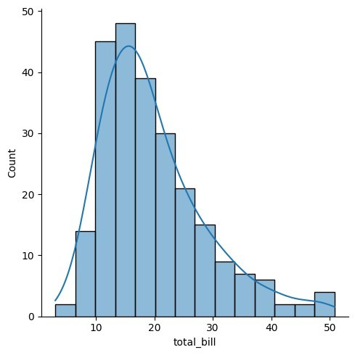

sns.displot(tips.total_bill,kde=False)

<seaborn.axisgrid.FacetGrid at 0x20d7dc22790>

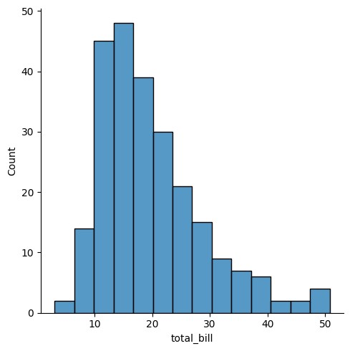

sns.jointplot(x=tips.tip,y=tips.total_bill)

<seaborn.axisgrid.JointGrid at 0x20d7dc2f2d0>

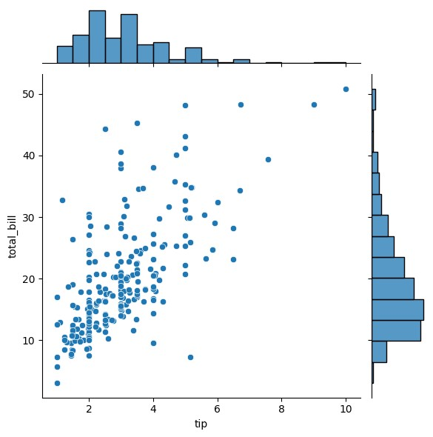

sns.jointplot(x=tips.tip,y=tips.total_bill,kind="reg")

<seaborn.axisgrid.JointGrid at 0x20d7ed32450>

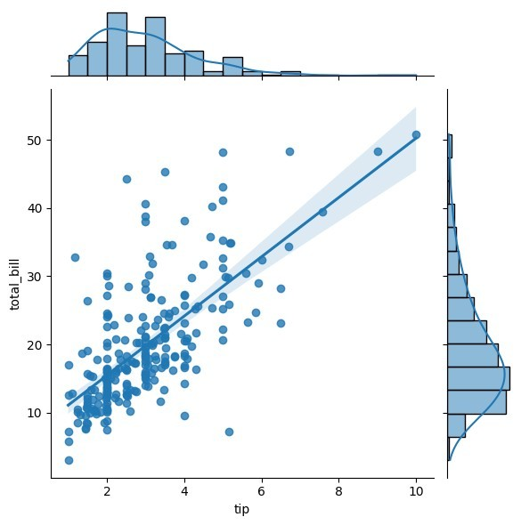

sns.jointplot(x=tips.tip,y=tips.total_bill,kind="hex")

<seaborn.axisgrid.JointGrid at 0x20d7ed7d350>

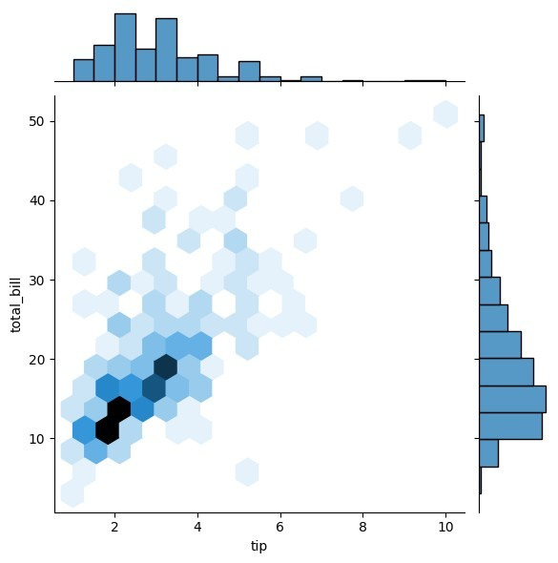

sns.pairplot(tips) <seaborn.axisgrid.PairGrid at 0x20d7f1c9cd0>

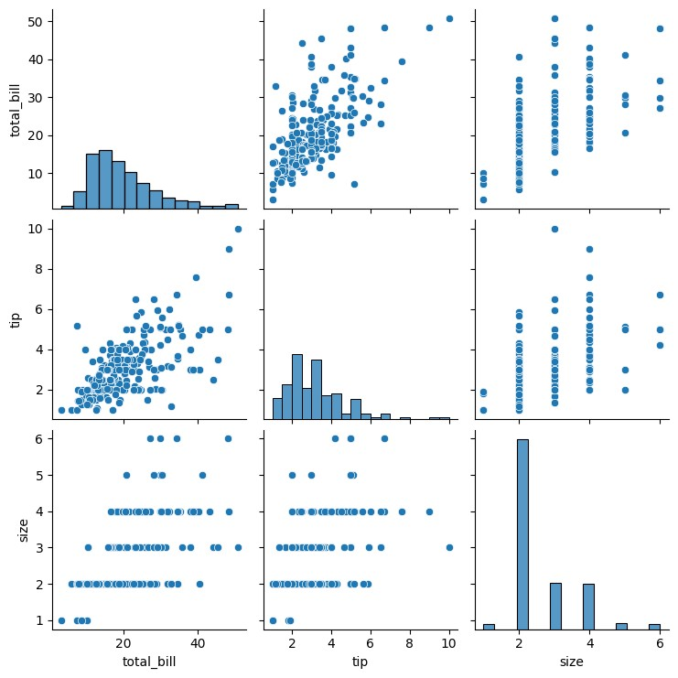

|  |  |  |  |  |  |  |  |  |  |
| --- | --- | --- | --- | --- | --- | --- | --- | --- | --- |
| tips.time.value_counts()   |  |  |  | | --- | --- | --- | | time |  | | | Dinner 176  Lunch 68 | |  | | Name: count, dtype: int64 | | |   sns.pairplot(tips,hue='time')  <seaborn.axisgrid.PairGrid at 0x20d7cc27990> |

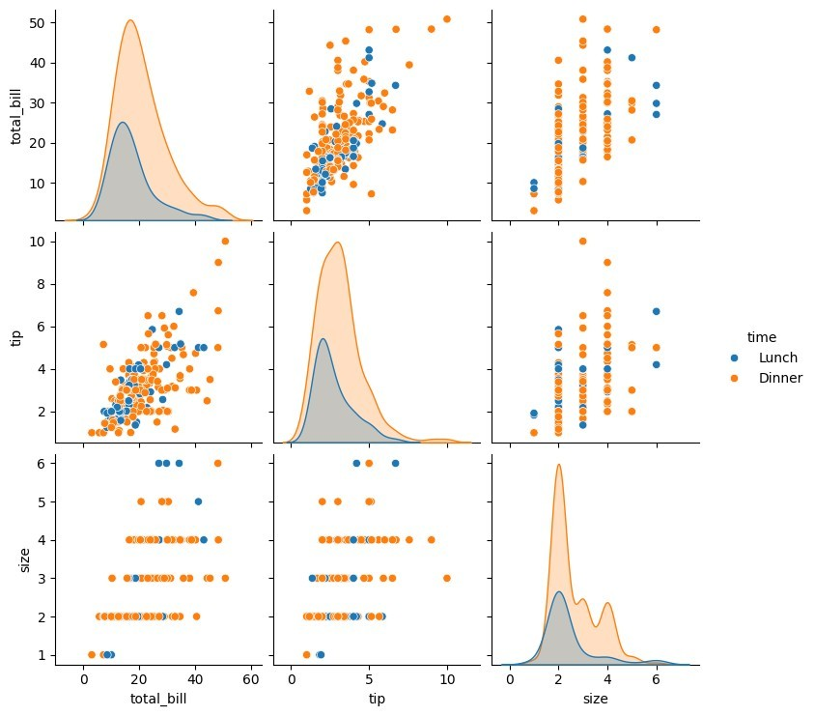

sns.heatmap(tips.corr(numeric_only=True),annot=True)

<Axes: >

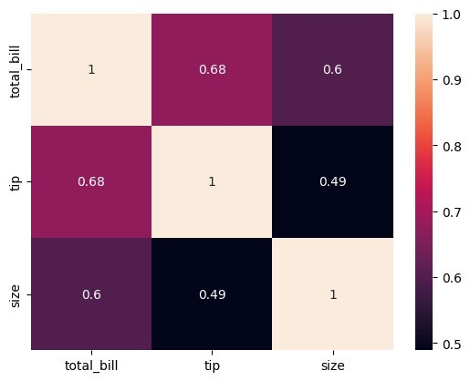

sns.boxplot(tips.total_bill) <Axes: ylabel='total_bill'>

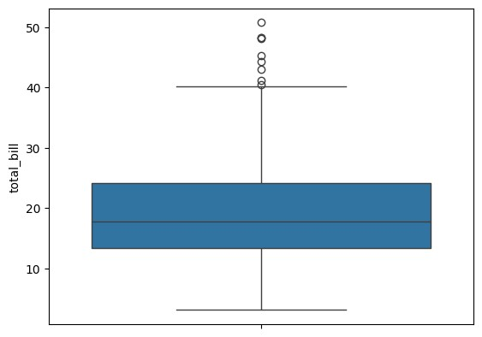

sns.boxplot(tips.tip) <Axes: ylabel='tip'>

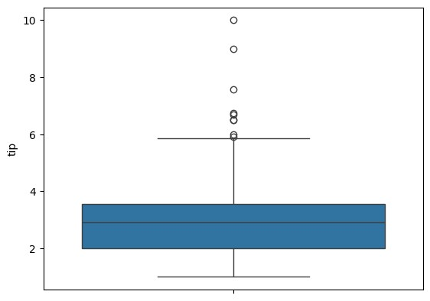

sns.countplot(tips.day) <Axes: xlabel='count', ylabel='day'>

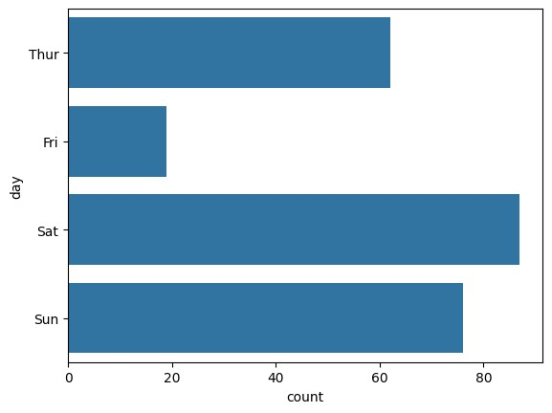

sns.countplot(tips.sex)

<Axes: xlabel='count', ylabel='sex'>

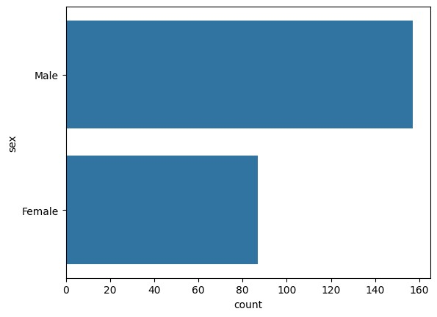

tips.sex.value_counts().plot(kind='pie')

<Axes: ylabel='count'>

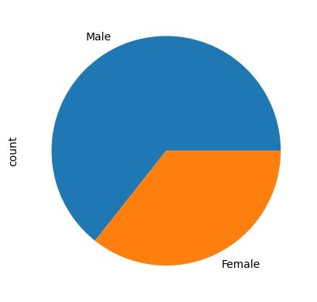

tips.sex.value_counts().plot(kind='bar')

<Axes: xlabel='sex'>

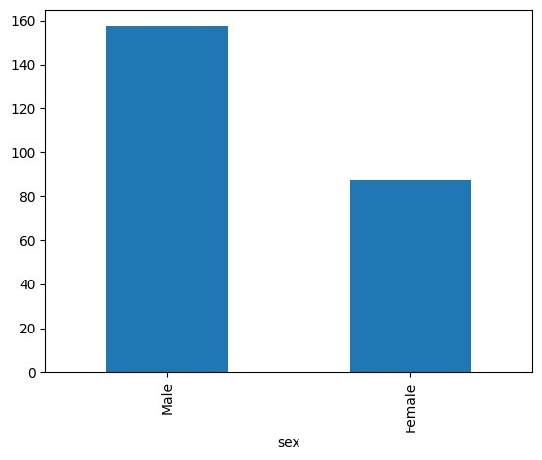

sns.countplot(tips[tips.time=='Dinner']['day'])

<Axes: xlabel='count', ylabel='day'>

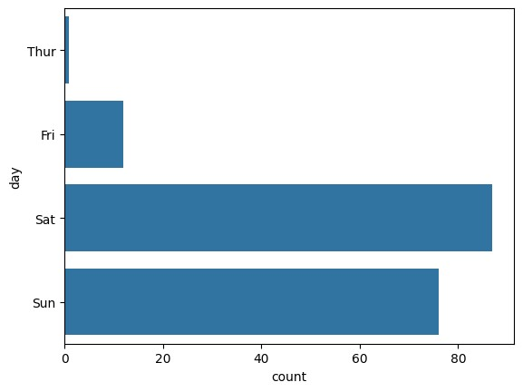

|  |
| --- |
| *#EX.NO :6 Random Sampling and Sampling Distribution*  *#DATA : 10.09.2024*  *#NAME : VISHVAA.J*  *#ROLL NO : 230701509*  *#DEPARTMENT : B.E COMPUTER SCIENCE AND ENGINEERING – SECTION-D*  import numpy as np  import matplotlib.pyplot as plt  population_mean = 50 population_std = 10 population_size = 100000  population = np.random.normal(population_mean, population_std, population_size)  sample_sizes = [30, 50, 100] num_samples = 1000  sample_means = {} for size in sample_sizes: sample_means[size] = [] for _ in range(num_samples): sample = np.random.choice(population, size=size, replace=False) sample_means[size].append(np.mean(sample)) |
| plt.figure(figsize=(12, 8))   |  | | --- | | <Figure size 1200x800 with 0 Axes> | | <Figure size 1200x800 with 0 Axes> |   for i, size in enumerate(sample_sizes): plt.subplot(len(sample_sizes), 1, i+1)  plt.hist(sample_means[size], bins=30, alpha=0.7, label=f'Sample Size {size}')  plt.axvline(np.mean(population), color='red', linestyle= 'dashed', linewidth=1.5,  label= 'Population Mean')  plt.title(f'Sampling Distribution(Sample Size {size})') plt.xlabel('Sample mean') plt.ylabel('Frequency') plt.legend() plt.tight_layout()  plt.show() |

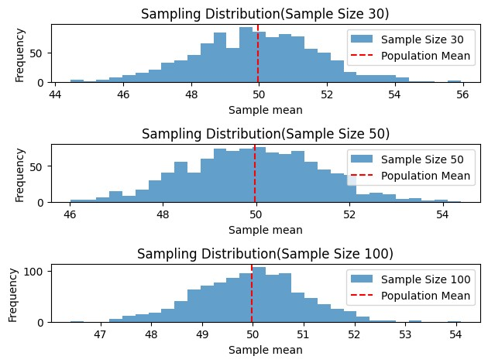

*#EX.NO :7 Z-Test*

*#DATA : 10.09.2024*

|  |  |  |  |  |
| --- | --- | --- | --- | --- |
| *#NAME : VISHVAA.J*  *#ROLL NO : 230701509*  *#DEPARTMENT : B.E COMPUTER SCIENCE AND ENGINEERING – SECTION-D*  import numpy as np import scipy.stats as stats  sample_data = np.array([152, 148, 151, 149, 147, 153, 150, 148, 152,  149,151, 150, 149, 152, 151, 148, 150, 152, 149, 150,148, 153, 151,  150, 149, 152, 148, 151, 150, 153])  population_mean = 150  sample_mean = np.mean(sample_data) sample_std = np.std(sample_data, ddof=1)  n = len(sample_data)  z_statistic = (sample_mean - population_mean) / (sample_std / np.sqrt(n))  p_value = 2 * (1 - stats.norm.cdf(np.abs(z_statistic)))  *# Assuming sample_mean, z_statistic, and p_value have already been calculated:* print(f"Sample Mean: {sample_mean:.2f}\n") print(f"Z-Statistic: {z_statistic:.4f}\n") print(f"P-Value: {p_value:.4f}\n")  *# Significance level* alpha = 0.05  *# Decision based on p-value* if p_value < alpha: print("Reject the null hypothesis: The average weight is significantly different from 150 grams.") else: print("Fail to reject the null hypothesis: There is no significant difference in average weight from 150 grams.")  Sample Mean: 150.20  Z-Statistic: 0.6406  P-Value: 0.5218   |  |  | | --- | --- | | Fail to reject the null hypothesis: There is no significant difference | | | in average weight from 150 grams. |  |   *#EX.NO :8 T-Test*  *#DATA : 08.10.2024*  *#NAME : VISHVAA.J* |

|  |  |  |  |  |  |
| --- | --- | --- | --- | --- | --- |
| *#ROLL NO : 230701509*  *#DEPARTMENT : B.E COMPUTER SCIENCE AND ENGINEERING – SECTION-D*  import numpy as np import scipy.stats as stats np.random.seed(42) sample_size = 25  sample_data = np.random.normal(loc=102, scale=15, size=sample_size)  population_mean = 100  sample_mean = np.mean(sample_data) sample_std = np.std(sample_data, ddof=1)  n = len(sample_data)  t_statistic, p_value = stats.ttest_1samp(sample_data,population_mean)  *# Assuming sample_mean, t_statistic, and p_value have already been calculated:* print(f"Sample Mean: {sample_mean:.2f}\n") print(f"T-Statistic: {t_statistic:.4f}\n") print(f"P-Value: {p_value:.4f}\n")  *# Significance level* alpha = 0.05  *# Decision based on p-value* if p_value < alpha: print("Reject the null hypothesis: The average IQ score is significantly different from 100.") else: print("Fail to reject the null hypothesis: There is no significant difference in average IQ score from 100.")  Sample Mean: 99.55  T-Statistic: -0.1577  P-Value: 0.8760   |  |  | | --- | --- | | Fail to reject the null hypothesis: There is no significant difference | | | in average IQ score from 100. |  |  |  | | --- | | **TEST** |   *#EX.NO :9 Annova*  *#DATA : 08.10.2024*  *#NAME : VISHVAA.J*  *#ROLL NO : 230701509*  *#DEPARTMENT : B.E COMPUTER SCIENCE AND ENGINEERING – SECTION-D*  import numpy as np import scipy.stats as stats |

|  |  |  |  |  |
| --- | --- | --- | --- | --- |
| from statsmodels.stats.multicomp import pairwise_tukeyhsd  np.random.seed(42) n_plants = 25  growth_A = np.random.normal(loc=10, scale=2, size=n_plants) growth_B = np.random.normal(loc=12, scale=3, size=n_plants) growth_C = np.random.normal(loc=15, scale=2.5, size=n_plants) all_data = np.concatenate([growth_A, growth_B, growth_C])  treatment_labels = ['A'] * n_plants + ['B'] * n_plants + ['C'] * n_plants  f_statistic, p_value = stats.f_oneway(growth_A, growth_B, growth_C)  mean_A = np.mean(growth_A) mean_B = np.mean(growth_B) mean_C = np.mean(growth_C)  print(f"Treatment A Mean Growth: {mean_A:.4f}") print(f"Treatment B Mean Growth: {mean_B:.4f}") print(f"Treatment C Mean Growth: {mean_C:.4f}") print(f"F-Statistic: {f_statistic:.4f}") print(f"P-Value: {p_value:.4f}")  alpha = 0.05 if p_value < alpha: print("Reject the null hypothesis: There is a significant difference in mean growth rates among the three treatments.") else: print("Fail to reject the null hypothesis: There is no significant difference in mean growth rates among the three treatments.")  if p_value < alpha:    tukey_results = pairwise_tukeyhsd(all_data, treatment_labels, alpha=0.05)  print("\nTukey's HSD Post-hoc Test:") print(tukey_results)  Treatment A Mean Growth: 9.6730  Treatment B Mean Growth: 11.1377  Treatment C Mean Growth: 15.2652  F-Statistic: 36.1214  P-Value: 0.0000  Reject the null hypothesis: There is a significant difference in mean growth rates among the three treatments.   |  |  | | --- | --- | | Tukey's HSD Post-hoc Test: |  | | Multiple Comparison of Means - Tukey HSD, FWER=0.05 | | |

|  |  |  |
| --- | --- | --- |
| |  | | --- | | =================================================== group1 group2 meandiff p-adj lower upper reject ---------------------------------------------------  A B 1.4647 0.0877 -0.1683 3.0977 False   1. C 5.5923 0.0 3.9593 7.2252 True 2. C 4.1276 0.0 2.4946 5.7605 True   --------------------------------------------------- |   *#EX.NO :10 Feature Scaling*  *#DATA : 22.10.2024*  *#NAME : VISHVAA.J*  *#ROLL NO : 230701509*  *#DEPARTMENT : B.E COMPUTER SCIENCE AND ENGINEERING – SECTION-D*  import numpy as np import pandas as pd import warnings  warnings.filterwarnings('ignore')  df=pd.read_csv('pre_process_datasample.csv') df.head()   |  | | --- | | Country Age Salary Purchased   1. France 44.0 72000.0 No 2. Spain 27.0 48000.0 Yes 3. Germany 30.0 54000.0 No 4. Spain 38.0 61000.0 No 5. Germany 40.0 NaN Yes |   df.Country.fillna(df.Country.mode()[0],inplace=True) features=df.iloc[:,:-1].values features  array([['France', 44.0, 72000.0], ['Spain', 27.0, 48000.0],  ['Germany', 30.0, 54000.0],  ['Spain', 38.0, 61000.0],  ['Germany', 40.0, nan],  ['France', 35.0, 58000.0],  ['Spain', nan, 52000.0],  ['France', 48.0, 79000.0],  ['Germany', 50.0, 83000.0],  ['France', 37.0, 67000.0]], dtype=object) label=df.iloc[:,-1].values  from sklearn.impute import SimpleImputer  age=SimpleImputer(strategy="mean",missing_values=np.nan) Salary=SimpleImputer(strategy="mean",missing_values=np.nan) age.fit(features[:,[1]]) |

|  |  |  |  |  |  |  |  |  |  |  |  |  |  |  |
| --- | --- | --- | --- | --- | --- | --- | --- | --- | --- | --- | --- | --- | --- | --- |
| |  | | --- | | SimpleImputer() |   Salary.fit(features[:,[2]])   |  | | --- | | SimpleImputer() |   SimpleImputer()   |  | | --- | | SimpleImputer() |   features[:,[1]]=age.transform(features[:,[1]]) features[:,[2]]=Salary.transform(features[:,[2]]) features  array([['France', 44.0, 72000.0], ['Spain', 27.0, 48000.0],  ['Germany', 30.0, 54000.0],  ['Spain', 38.0, 61000.0],  ['Germany', 40.0, 63777.77777777778],  ['France', 35.0, 58000.0],  ['Spain', 38.77777777777778, 52000.0],  ['France', 48.0, 79000.0],  ['Germany', 50.0, 83000.0],  ['France', 37.0, 67000.0]], dtype=object)  from sklearn.preprocessing import OneHotEncoder oh = OneHotEncoder(sparse_output=False) Country=oh.fit_transform(features[:,[0]]) Country  array([[1., 0., 0.], [0., 0., 1.],  [0., 1., 0.],  [0., 0., 1.],  [0., 1., 0.],  [1., 0., 0.],  [0., 0., 1.],  [1., 0., 0.],  [0., 1., 0.],  [1., 0., 0.]])  final_set=np.concatenate((Country,features[:,[1,2]]),axis=1) final_set   |  |  |  | | --- | --- | --- | | array([[1.0, 0.0, 0.0, 44.0, 72000.0], [0.0, 0.0, 1.0, 27.0, 48000.0],  [0.0, 1.0, 0.0, 30.0, 54000.0],  [0.0, 0.0, 1.0, 38.0, 61000.0], |  | | | [0.0, 1.0, 0.0, 40.0, 63777.77777777778], | |  | | [1.0, 0.0, 0.0, 35.0, 58000.0], |  | | [0.0, 0.0, 1.0, 38.77777777777778, 52000.0], | | | |

[1.0, 0.0, 0.0, 48.0, 79000.0],

[0.0, 1.0, 0.0, 50.0, 83000.0],

[1.0, 0.0, 0.0, 37.0, 67000.0]], dtype=object)

from sklearn.preprocessing import StandardScaler sc=StandardScaler() sc.fit(final_set)

feat_standard_scaler=sc.transform(final_set) feat_standard_scaler

array([[ 1.22474487e+00, -6.54653671e-01, -6.54653671e-01,

7.58874362e-01, 7.49473254e-01],

[-8.16496581e-01, -6.54653671e-01, 1.52752523e+00,

-1.71150388e+00, -1.43817841e+00],

[-8.16496581e-01, 1.52752523e+00, -6.54653671e-01,

-1.27555478e+00, -8.91265492e-01],

[-8.16496581e-01, -6.54653671e-01, 1.52752523e+00,

-1.13023841e-01, -2.53200424e-01],

[-8.16496581e-01, 1.52752523e+00, -6.54653671e-01,

1.77608893e-01, 6.63219199e-16],

[ 1.22474487e+00, -6.54653671e-01, -6.54653671e-01,

-5.48972942e-01, -5.26656882e-01],

[-8.16496581e-01, -6.54653671e-01, 1.52752523e+00,

0.00000000e+00, -1.07356980e+00],

[ 1.22474487e+00, -6.54653671e-01, -6.54653671e-01,

1.34013983e+00, 1.38753832e+00],

[-8.16496581e-01, 1.52752523e+00, -6.54653671e-01,

1.63077256e+00, 1.75214693e+00],

[ 1.22474487e+00, -6.54653671e-01, -6.54653671e-01,

-2.58340208e-01, 2.93712492e-01]])

from sklearn.preprocessing import MinMaxScaler mms=MinMaxScaler(feature_range=(0,1)) mms.fit(final_set)

feat_minmax_scaler=mms.transform(final_set) feat_minmax_scaler

array([[1. , 0. , 0. , 0.73913043, 0.68571429], [0. , 0. , 1. , 0. , 0. ],

[0. , 1. , 0. , 0.13043478, 0.17142857],

[0. , 0. , 1. , 0.47826087, 0.37142857],

1. , 1. , 0. , 0.56521739, 0.45079365],
2. , 0. , 0. , 0.34782609, 0.28571429],
3. , 0. , 1. , 0.51207729, 0.11428571],
4. , 0. , 0. , 0.91304348, 0.88571429],
5. , 1. , 0. , 1. , 1. ],
6. , 0. , 0. , 0.43478261, 0.54285714]])

*#EX.NO :11 Linear Regression*

*#DATA : 29.10.2024*

|  |  |  |  |  |  |  |  |  |  |
| --- | --- | --- | --- | --- | --- | --- | --- | --- | --- |
| *#NAME : VISHVAA.J*  *#ROLL NO : 230701509*  *#DEPARTMENT : B.E COMPUTER SCIENCE AND ENGINEERING – SECTION-D*  import numpy as np import pandas as pd  df = pd.read_csv('Salary_data.csv') df   |  | | --- | | YearsExperience Salary   1. 1.1 39343 2. 1.3 46205 3. 1.5 37731 4. 2.0 43525 5. 2.2 39891 6. 2.9 56642 7. 3.0 60150 8. 3.2 54445 9. 3.2 64445 10. 3.7 57189 11. 3.9 63218 12. 4.0 55794 13. 4.0 56957 14. 4.1 57081 15. 4.5 61111 16. 4.9 67938 17. 5.1 66029 18. 5.3 83088 19. 5.9 81363 20. 6.0 93940 21. 6.8 91738 22. 7.1 98273 23. 7.9 101302 24. 8.2 113812 25. 8.7 109431 26. 9.0 105582 27. 9.5 116969 28. 9.6 112635 29. 10.3 122391 30. 10.5 121872 |   df.info()   |  |  |  | | --- | --- | --- | | <class 'pandas.core.frame.DataFrame'> | |  | | RangeIndex: 30 entries, 0 to 29 Data columns (total 2 columns): |  | | # Column Non-Null Count Dtype  --- ------ -------------- ----- | | | |

|  |  |  |  |  |  |  |  |  |  |  |  |  |  |  |
| --- | --- | --- | --- | --- | --- | --- | --- | --- | --- | --- | --- | --- | --- | --- |
| |  |  |  |  | | --- | --- | --- | --- | | 0 YearsExperience 30 non-null float64 | | | | | 1 Salary 30 non-null int64 | | |  | | dtypes: float64(1), int64(1) | |  | | memory usage: 612.0 bytes |  |   df.dropna(inplace=True); df   |  | | --- | | YearsExperience Salary   1. 1.1 39343 2. 1.3 46205 3. 1.5 37731 4. 2.0 43525 5. 2.2 39891 6. 2.9 56642 7. 3.0 60150 8. 3.2 54445 9. 3.2 64445 10. 3.7 57189 11. 3.9 63218 12. 4.0 55794 13. 4.0 56957 14. 4.1 57081 15. 4.5 61111 16. 4.9 67938 17. 5.1 66029 18. 5.3 83088 19. 5.9 81363 20. 6.0 93940 21. 6.8 91738 22. 7.1 98273 23. 7.9 101302 24. 8.2 113812 25. 8.7 109431 26. 9.0 105582 27. 9.5 116969 28. 9.6 112635 29. 10.3 122391 30. 10.5 121872 |   df.info()  <class 'pandas.core.frame.DataFrame'>  RangeIndex: 30 entries, 0 to 29 Data columns (total 2 columns):  # Column Non-Null Count Dtype  --- ------ -------------- -----   1. YearsExperience 30 non-null float64 2. Salary 30 non-null int64 |

|  |  |  |  |  |  |  |
| --- | --- | --- | --- | --- | --- | --- |
| |  |  | | --- | --- | | dtypes: float64(1), int64(1) | | | memory usage: 612.0 bytes |  |   df.describe() *#descripte statical report # find out lYER FOR BELOW META DATA*   |  | | --- | | YearsExperience Salary count 30.000000 30.000000 mean 5.313333 76003.000000 std 2.837888 27414.429785 min 1.100000 37731.000000 25% 3.200000 56720.750000  50% 4.700000 65237.000000 75% 7.700000 100544.750000 max 10.500000 122391.000000 |   features = df.iloc[:,[0]].values *# : - > all row , 0 -> first column*  *#iloc index based selection loc location based sentence*  label = df.iloc[:,[1]].values  features   |  | | --- | | array([[ 1.1], [ 1.3],  [ 1.5],  [ 2. ],  [ 2.2],  [ 2.9],  [ 3. ],  [ 3.2],  [ 3.2],  [ 3.7],  [ 3.9],  [ 4. ],  [ 4. ],  [ 4.1],  [ 4.5],  [ 4.9],  [ 5.1],  [ 5.3],  [ 5.9],  [ 6. ],  [ 6.8],  [ 7.1],  [ 7.9],  [ 8.2],  [ 8.7],  [ 9. ], | |

|  |  |  |  |  |  |  |  |  |
| --- | --- | --- | --- | --- | --- | --- | --- | --- |
| [ 9.5],  [ 9.6],  [10.3],  [10.5]]) label   |  |  | | --- | --- | | array([[ 39343], [ 46205],  [ 37731],  [ 43525],  [ 39891],  [ 56642],  [ 60150],  [ 54445],  [ 64445],  [ 57189],  [ 63218],  [ 55794],  [ 56957],  [ 57081],  [ 61111],  [ 67938],  [ 66029],  [ 83088],  [ 81363],  [ 93940],  [ 91738],  [ 98273],  [101302],  [113812],  [109431],  [105582],  [116969],  [112635],  [122391], |  | | [121872]], dtype=int64) | |   from sklearn.model_selection import train_test_split x_train,x_test,y_train,y_test =  train_test_split(features,label,test_size=0.2,random_state=23)  *# x independent input train 80 % test 20 %*  *'''*  *y is depenent ouput*  *0.2 allocate test for 20 % automatically train for 80 %*  *'''*   |  |  | | --- | --- | | '\ny is depenent ouput\n0.2 allocate test for 20 % automatically train | | | for 80 %\n' |  | |

|  |  |  |  |  |  |  |  |  |  |
| --- | --- | --- | --- | --- | --- | --- | --- | --- | --- |
| from sklearn.linear_model import LinearRegression model = LinearRegression() model.fit(x_train,y_train)  *'''*  *sk - size kit*  *linear means using linear regression*  *fit means add data '''*   |  |  | | --- | --- | | '\nsk - size kit \nlinear means using linear regression \nfit means | | | add data \n' |  |   model.score(x_train,y_train)  *'''*  *accuracy calculating*  *96 %*  *'''*   |  | | --- | | '\naccuracy calculating\n96 %\n' |   model.score(x_test,y_test)  *'''*  *accuracy calculating*  *91 %*  *'''*   |  | | --- | | '\naccuracy calculating\n91 %\n' |   model.coef_   |  | | --- | | array([[9281.30847068]]) |   model.intercept_   |  | | --- | | array([27166.73682891]) |   import pickle  pickle.dump(model,open('SalaryPred.model','wb'))  *'''*  *pickle momory obj to file '''*   |  | | --- | | '\npickle momory obj to file\n\n' |   model = pickle.load(open('SalaryPred.model','rb'))  yr_of_exp = float(input("Enter years of expreience: ")) yr_of_exp_NP = np.array([[yr_of_exp]]) salary = model.predict(yr_of_exp_NP) print("Estimated salary for {} years of expreience is {} .  ".format(yr_of_exp,salary)) |

|  |  |  |  |  |  |  |  |  |  |
| --- | --- | --- | --- | --- | --- | --- | --- | --- | --- |
| |  | | --- | | Enter years of expreience: 24 |   Estimated salary for 24.0 years of expreience is [[249918.14012525]] .  print(f" Estimated salary for {yr_of_exp} years of expreience is {salary} . ")   |  |  | | --- | --- | | Estimated salary for 24.0 years of expreience is | | | [[249918.14012525]] | . |   *#EX.NO :12 Logistic Regression*  *#DATA : 05.11.2024*  *#NAME : VISHVAA.J*  *#ROLL NO : 230701509*  *#DEPARTMENT : B.E COMPUTER SCIENCE AND ENGINEERING – SECTION-D*  import numpy as np import pandas as pd import warnings  warnings.filterwarnings('ignore')  df=pd.read_csv('Social_Network_Ads.csv.csv') df   |  |  | | --- | --- | | User ID Gender Age EstimatedSalary Purchased   1. 15624510 Male 19 19000 0 2. 15810944 Male 35 20000 0 3. 15668575 Female 26 43000 0 4. 15603246 Female 27 57000 0 5. 15804002 Male 19 76000 0 .. ... ... ... ... ... 6. 15691863 Female 46 41000 1 7. 15706071 Male 51 23000 1 8. 15654296 Female 50 20000 1 9. 15755018 Male 36 33000 0 10. 15594041 Female 49 36000 1 | | | [400 rows x 5 columns] |   df.tail(20)   |  | | --- | | User ID Gender Age EstimatedSalary Purchased   1. 15683758 Male 42 64000 0 2. 15670615 Male 48 33000 1 3. 15715622 Female 44 139000 1 4. 15707634 Male 49 28000 1 5. 15806901 Female 57 33000 1 6. 15775335 Male 56 60000 1 7. 15724150 Female 49 39000 1 8. 15627220 Male 39 71000 0 | |

|  |  |  |  |
| --- | --- | --- | --- |
| |  | | --- | | 1. 15672330 Male 47 34000 1 2. 15668521 Female 48 35000 1 3. 15807837 Male 48 33000 1 4. 15592570 Male 47 23000 1 5. 15748589 Female 45 45000 1 6. 15635893 Male 60 42000 1 7. 15757632 Female 39 59000 0 8. 15691863 Female 46 41000 1 9. 15706071 Male 51 23000 1 10. 15654296 Female 50 20000 1 11. 15755018 Male 36 33000 0 12. 15594041 Female 49 36000 1 |   df.head(25)   |  | | --- | | User ID Gender Age EstimatedSalary Purchased   1. 15624510 Male 19 19000 0 2. 15810944 Male 35 20000 0 3. 15668575 Female 26 43000 0 4. 15603246 Female 27 57000 0 5. 15804002 Male 19 76000 0 6. 15728773 Male 27 58000 0 7. 15598044 Female 27 84000 0 8. 15694829 Female 32 150000 1 9. 15600575 Male 25 33000 0 10. 15727311 Female 35 65000 0 11. 15570769 Female 26 80000 0 12. 15606274 Female 26 52000 0 13. 15746139 Male 20 86000 0 14. 15704987 Male 32 18000 0 15. 15628972 Male 18 82000 0 16. 15697686 Male 29 80000 0 17. 15733883 Male 47 25000 1 18. 15617482 Male 45 26000 1 19. 15704583 Male 46 28000 1 20. 15621083 Female 48 29000 1 21. 15649487 Male 45 22000 1 22. 15736760 Female 47 49000 1 23. 15714658 Male 48 41000 1 24. 15599081 Female 45 22000 1 25. 15705113 Male 46 23000 1 |   features = df.iloc[:,[2,3]].values label = df.iloc[:,4].values features   |  | | --- | | array([[ 19, 19000], [ 35, 20000],  [ 26, 43000],  [ 27, 57000], | |

|  |  |
| --- | --- |
| |  | | --- | | [ 19, 76000],  [ 27, 58000],  [ 27, 84000],  [ 32, 150000],  [ 25, 33000],  [ 35, 65000],  [ 26, 80000],  [ 26, 52000],  [ 20, 86000],  [ 32, 18000],  [ 18, 82000],  [ 29, 80000],  [ 47, 25000],  [ 45, 26000],  [ 46, 28000],  [ 48, 29000],  [ 45, 22000],  [ 47, 49000],  [ 48, 41000],  [ 45, 22000],  [ 46, 23000],  [ 47, 20000],  [ 49, 28000],  [ 47, 30000],  [ 29, 43000],  [ 31, 18000],  [ 31, 74000],  [ 27, 137000],  [ 21, 16000],  [ 28, 44000],  [ 27, 90000],  [ 35, 27000],  [ 33, 28000],  [ 30, 49000],  [ 26, 72000],  [ 27, 31000],  [ 27, 17000],  [ 33, 51000],  [ 35, 108000],  [ 30, 15000],  [ 28, 84000],  [ 23, 20000],  [ 25, 79000],  [ 27, 54000],  [ 30, 135000],  [ 31, 89000],  [ 24, 32000],  [ 18, 44000], |   [ 29, 83000], |

|  |  |
| --- | --- |
| |  | | --- | | [ 35, 23000],  [ 27, 58000],  [ 24, 55000],  [ 23, 48000],  [ 28, 79000],  [ 22, 18000],  [ 32, 117000],  [ 27, 20000],  [ 25, 87000],  [ 23, 66000],  [ 32, 120000],  [ 59, 83000],  [ 24, 58000],  [ 24, 19000],  [ 23, 82000],  [ 22, 63000],  [ 31, 68000],  [ 25, 80000],  [ 24, 27000],  [ 20, 23000],  [ 33, 113000],  [ 32, 18000],  [ 34, 112000],  [ 18, 52000],  [ 22, 27000],  [ 28, 87000],  [ 26, 17000],  [ 30, 80000],  [ 39, 42000],  [ 20, 49000],  [ 35, 88000],  [ 30, 62000],  [ 31, 118000],  [ 24, 55000],  [ 28, 85000],  [ 26, 81000],  [ 35, 50000],  [ 22, 81000],  [ 30, 116000],  [ 26, 15000],  [ 29, 28000],  [ 29, 83000],  [ 35, 44000],  [ 35, 25000],  [ 28, 123000],  [ 35, 73000],  [ 28, 37000],  [ 27, 88000], |   [ 28, 59000], |

|  |  |
| --- | --- |
| |  | | --- | | [ 32, 86000],  [ 33, 149000],  [ 19, 21000],  [ 21, 72000],  [ 26, 35000],  [ 27, 89000],  [ 26, 86000],  [ 38, 80000],  [ 39, 71000],  [ 37, 71000],  [ 38, 61000],  [ 37, 55000],  [ 42, 80000],  [ 40, 57000],  [ 35, 75000],  [ 36, 52000],  [ 40, 59000],  [ 41, 59000],  [ 36, 75000],  [ 37, 72000],  [ 40, 75000],  [ 35, 53000],  [ 41, 51000],  [ 39, 61000],  [ 42, 65000],  [ 26, 32000],  [ 30, 17000],  [ 26, 84000],  [ 31, 58000],  [ 33, 31000],  [ 30, 87000],  [ 21, 68000],  [ 28, 55000],  [ 23, 63000],  [ 20, 82000],  [ 30, 107000],  [ 28, 59000],  [ 19, 25000],  [ 19, 85000],  [ 18, 68000],  [ 35, 59000],  [ 30, 89000],  [ 34, 25000],  [ 24, 89000],  [ 27, 96000],  [ 41, 30000],  [ 29, 61000],  [ 20, 74000], |   [ 26, 15000], |

|  |  |
| --- | --- |
| |  | | --- | | [ 41, 45000],  [ 31, 76000],  [ 36, 50000],  [ 40, 47000],  [ 31, 15000],  [ 46, 59000],  [ 29, 75000],  [ 26, 30000],  [ 32, 135000],  [ 32, 100000],  [ 25, 90000],  [ 37, 33000],  [ 35, 38000],  [ 33, 69000],  [ 18, 86000],  [ 22, 55000],  [ 35, 71000],  [ 29, 148000],  [ 29, 47000],  [ 21, 88000],  [ 34, 115000],  [ 26, 118000],  [ 34, 43000],  [ 34, 72000],  [ 23, 28000],  [ 35, 47000],  [ 25, 22000],  [ 24, 23000],  [ 31, 34000],  [ 26, 16000],  [ 31, 71000],  [ 32, 117000],  [ 33, 43000],  [ 33, 60000],  [ 31, 66000],  [ 20, 82000],  [ 33, 41000],  [ 35, 72000],  [ 28, 32000],  [ 24, 84000],  [ 19, 26000],  [ 29, 43000],  [ 19, 70000],  [ 28, 89000],  [ 34, 43000],  [ 30, 79000],  [ 20, 36000],  [ 26, 80000], |   [ 35, 22000], |

|  |  |
| --- | --- |
| |  | | --- | | [ 35, 39000],  [ 49, 74000],  [ 39, 134000],  [ 41, 71000],  [ 58, 101000],  [ 47, 47000],  [ 55, 130000],  [ 52, 114000],  [ 40, 142000],  [ 46, 22000],  [ 48, 96000],  [ 52, 150000],  [ 59, 42000],  [ 35, 58000],  [ 47, 43000],  [ 60, 108000],  [ 49, 65000],  [ 40, 78000],  [ 46, 96000],  [ 59, 143000],  [ 41, 80000],  [ 35, 91000],  [ 37, 144000],  [ 60, 102000],  [ 35, 60000],  [ 37, 53000],  [ 36, 126000],  [ 56, 133000],  [ 40, 72000],  [ 42, 80000],  [ 35, 147000],  [ 39, 42000],  [ 40, 107000],  [ 49, 86000],  [ 38, 112000],  [ 46, 79000],  [ 40, 57000],  [ 37, 80000],  [ 46, 82000],  [ 53, 143000],  [ 42, 149000],  [ 38, 59000],  [ 50, 88000],  [ 56, 104000],  [ 41, 72000],  [ 51, 146000],  [ 35, 50000],  [ 57, 122000], |   [ 41, 52000], |

|  |  |
| --- | --- |
| |  | | --- | | [ 35, 97000],  [ 44, 39000],  [ 37, 52000],  [ 48, 134000],  [ 37, 146000],  [ 50, 44000],  [ 52, 90000],  [ 41, 72000],  [ 40, 57000],  [ 58, 95000],  [ 45, 131000],  [ 35, 77000],  [ 36, 144000],  [ 55, 125000],  [ 35, 72000],  [ 48, 90000],  [ 42, 108000],  [ 40, 75000],  [ 37, 74000],  [ 47, 144000],  [ 40, 61000],  [ 43, 133000],  [ 59, 76000],  [ 60, 42000],  [ 39, 106000],  [ 57, 26000],  [ 57, 74000],  [ 38, 71000],  [ 49, 88000],  [ 52, 38000],  [ 50, 36000],  [ 59, 88000],  [ 35, 61000],  [ 37, 70000],  [ 52, 21000],  [ 48, 141000],  [ 37, 93000],  [ 37, 62000],  [ 48, 138000],  [ 41, 79000],  [ 37, 78000],  [ 39, 134000],  [ 49, 89000],  [ 55, 39000],  [ 37, 77000],  [ 35, 57000],  [ 36, 63000],  [ 42, 73000], |   [ 43, 112000], |

|  |  |
| --- | --- |
| |  | | --- | | [ 45, 79000],  [ 46, 117000],  [ 58, 38000],  [ 48, 74000],  [ 37, 137000],  [ 37, 79000],  [ 40, 60000],  [ 42, 54000],  [ 51, 134000],  [ 47, 113000],  [ 36, 125000],  [ 38, 50000],  [ 42, 70000],  [ 39, 96000],  [ 38, 50000],  [ 49, 141000],  [ 39, 79000],  [ 39, 75000],  [ 54, 104000],  [ 35, 55000],  [ 45, 32000],  [ 36, 60000],  [ 52, 138000],  [ 53, 82000],  [ 41, 52000],  [ 48, 30000],  [ 48, 131000],  [ 41, 60000],  [ 41, 72000],  [ 42, 75000],  [ 36, 118000],  [ 47, 107000],  [ 38, 51000],  [ 48, 119000],  [ 42, 65000],  [ 40, 65000],  [ 57, 60000],  [ 36, 54000],  [ 58, 144000],  [ 35, 79000],  [ 38, 55000],  [ 39, 122000],  [ 53, 104000],  [ 35, 75000],  [ 38, 65000],  [ 47, 51000],  [ 47, 105000],  [ 41, 63000], |   [ 53, 72000], |

|  |  |  |
| --- | --- | --- |
|  | | |
|  | [ 54, 108000],  [ 39, 77000],  [ 38, 61000],  [ 38, 113000],  [ 37, 75000],  [ 42, 90000],  [ 37, 57000],  [ 36, 99000],  [ 60, 34000],  [ 54, 70000],  [ 41, 72000],  [ 40, 71000],  [ 42, 54000],  [ 43, 129000],  [ 53, 34000],  [ 47, 50000],  [ 42, 79000],  [ 42, 104000],  [ 59, 29000],  [ 58, 47000],  [ 46, 88000],  [ 38, 71000],  [ 54, 26000],  [ 60, 46000],  [ 60, 83000],  [ 39, 73000],  [ 59, 130000],  [ 37, 80000],  [ 46, 32000],  [ 46, 74000],  [ 42, 53000],  [ 41, 87000],  [ 58, 23000],  [ 42, 64000],  [ 48, 33000],  [ 44, 139000],  [ 49, 28000],  [ 57, 33000],  [ 56, 60000],  [ 49, 39000],  [ 39, 71000],  [ 47, 34000],  [ 48, 35000],  [ 48, 33000],  [ 47, 23000],  [ 45, 45000],  [ 60, 42000],  [ 39, 59000],  [ 46, 41000],  [ 51, 23000], |  |

|  |  |  |  |  |  |  |  |  |  |  |  |  |  |  |  |  |  |  |  |  |  |  |  |  |  |  |  |  |  |  |  |  |  |  |  |  |  |  |  |  |  |  |  |  |  |  |  |  |  |  |  |  |  |  |  |  |  |  |  |  |  |  |  |  |  |  |  |  |  |  |  |  |  |  |  |  |  |  |  |  |  |  |  |  |  |  |  |  |  |  |  |  |  |  |  |  |  |  |  |  |  |  |  |  |  |  |  |  |  |  |  |  |  |  |  |
| --- | --- | --- | --- | --- | --- | --- | --- | --- | --- | --- | --- | --- | --- | --- | --- | --- | --- | --- | --- | --- | --- | --- | --- | --- | --- | --- | --- | --- | --- | --- | --- | --- | --- | --- | --- | --- | --- | --- | --- | --- | --- | --- | --- | --- | --- | --- | --- | --- | --- | --- | --- | --- | --- | --- | --- | --- | --- | --- | --- | --- | --- | --- | --- | --- | --- | --- | --- | --- | --- | --- | --- | --- | --- | --- | --- | --- | --- | --- | --- | --- | --- | --- | --- | --- | --- | --- | --- | --- | --- | --- | --- | --- | --- | --- | --- | --- | --- | --- | --- | --- | --- | --- | --- | --- | --- | --- | --- | --- | --- | --- | --- | --- | --- | --- | --- |
| |  |  | | --- | --- | | [ 50, 20000],  [ 36, 33000], |  | | [ 49, 36000]], dtype=int64) | |   label   |  |  |  | | --- | --- | --- | | array([0, 0, 0, 0, 0, 0, 0, 1, 0, 0, 0, 0, 0, 0, 0, 0, 1, 1, 1, 1, 1, | | | | 1, |  | | | 1, 1, 1, 1, 1, 1, 0, 0, 0, 1, 0, 0, 0, 0, 0, 0, 0, 0, 0, 0, 0, | | | | 0, |  | | | 0, 0, 0, 0, 1, 0, 0, 0, 0, 0, 0, 0, 0, 0, 0, 0, 0, 0, 0, 1, 0, | | | | 0, |  | | | 0, 0, 0, 0, 0, 0, 0, 0, 0, 1, 0, 0, 0, 0, 0, 0, 0, 0, 0, 1, 0, | | | | 0, |  | | | 0, 0, 0, 0, 0, 0, 0, 0, 0, 1, 0, 0, 0, 0, 0, 1, 0, 0, 0, 0, 0, | | | | 0, |  | | | 0, 0, 0, 0, 0, 0, 0, 0, 0, 0, 0, 0, 0, 0, 0, 0, 0, 0, 0, 0, 0, | | | | 0, |  | | | 0, 0, 0, 0, 0, 1, 0, 0, 0, 0, 0, 0, 0, 0, 1, 0, 0, 0, 0, 0, 0, | | | | 0, |  | | | 0, 0, 0, 0, 0, 1, 1, 0, 0, 0, 0, 0, 0, 0, 1, 0, 0, 0, 0, 0, 0, | | | | 0, |  | | | 0, 0, 0, 0, 0, 0, 1, 0, 0, 0, 0, 0, 0, 0, 0, 0, 0, 0, 0, 0, 0, | | | | 0, |  | | | 0, 0, 0, 0, 1, 0, 1, 0, 1, 0, 1, 0, 1, 1, 0, 0, 0, 1, 0, 0, 0, | | | | 1, |  | | | 0, 1, 1, 1, 0, 0, 1, 1, 0, 1, 1, 0, 1, 1, 0, 1, 0, 0, 0, 1, 1, | | | | 0, |  | | | 1, 1, 0, 1, 0, 1, 0, 1, 0, 0, 1, 1, 0, 1, 0, 0, 1, 1, 0, 1, 1, | | | | 0, |  | | | 1, 1, 0, 0, 1, 0, 0, 1, 1, 1, 1, 1, 0, 1, 1, 1, 1, 0, 1, 1, 0, | | | | 1, |  | | | 0, 1, 0, 1, 1, 1, 1, 0, 0, 0, 1, 1, 0, 1, 1, 1, 1, 1, 0, 0, 0, | | | | 1, |  | | | 1, 0, 0, 1, 0, 1, 0, 1, 1, 0, 1, 0, 1, 1, 0, 1, 1, 0, 0, 0, 1, | | | | 1, |  | | | 0, 1, 0, 0, 1, 0, 1, 0, 0, 1, 1, 0, 0, 1, 1, 0, 1, 1, 0, 0, 1, | | | | 0, |  | | | 1, 0, 1, 1, 1, 0, 1, 0, 1, 1, 1, 0, 1, 1, 1, 1, 0, 1, 1, 1, 0, | | | | 1, |  | | | 0, 1, 0, 0, 1, 1, 0, 1, 1, 1, 1, 1, 1, 0, 1, 1, 1, 1, 1, 1, 0, | | | | 1, |  | | | 1, 1, 0, 1], dtype=int64) | |  |   from sklearn.model_selection import train_test_split from sklearn.linear_model import LogisticRegression *# Assuming `features` and `label` are already defined* for i in range(1, 401): |

x_train, x_test, y_train, y_test = train_test_split(features, label, test_size=0.2, random_state=i) model = LogisticRegression() model.fit(x_train, y_train)

train_score = model.score(x_train, y_train) test_score = model.score(x_test, y_test)

if test_score > train_score: print(f"Test Score: {test_score:.4f} | Train Score:

{train_score:.4f} | Random State: {i}")

*'''*

*'''*

Test Score: 0.9000 | Train Score: 0.8406 | Random State: 4

Test Score: 0.8625 | Train Score: 0.8500 | Random State: 5

Test Score: 0.8625 | Train Score: 0.8594 | Random State: 6

Test Score: 0.8875 | Train Score: 0.8375 | Random State: 7

Test Score: 0.8625 | Train Score: 0.8375 | Random State: 9

Test Score: 0.9000 | Train Score: 0.8406 | Random State: 10

Test Score: 0.8625 | Train Score: 0.8562 | Random State: 14

Test Score: 0.8500 | Train Score: 0.8438 | Random State: 15

Test Score: 0.8625 | Train Score: 0.8562 | Random State: 16

Test Score: 0.8750 | Train Score: 0.8344 | Random State: 18

Test Score: 0.8500 | Train Score: 0.8438 | Random State: 19

Test Score: 0.8750 | Train Score: 0.8438 | Random State: 20

Test Score: 0.8625 | Train Score: 0.8344 | Random State: 21

Test Score: 0.8750 | Train Score: 0.8406 | Random State: 22

Test Score: 0.8750 | Train Score: 0.8406 | Random State: 24

Test Score: 0.8500 | Train Score: 0.8344 | Random State: 26

Test Score: 0.8500 | Train Score: 0.8406 | Random State: 27

Test Score: 0.8625 | Train Score: 0.8344 | Random State: 30

Test Score: 0.8625 | Train Score: 0.8562 | Random State: 31

Test Score: 0.8750 | Train Score: 0.8531 | Random State: 32

Test Score: 0.8625 | Train Score: 0.8438 | Random State: 33

Test Score: 0.8750 | Train Score: 0.8313 | Random State: 35

Test Score: 0.8625 | Train Score: 0.8531 | Random State: 36

Test Score: 0.8875 | Train Score: 0.8406 | Random State: 38

Test Score: 0.8750 | Train Score: 0.8375 | Random State: 39

Test Score: 0.8875 | Train Score: 0.8375 | Random State: 42

Test Score: 0.8750 | Train Score: 0.8469 | Random State: 46

Test Score: 0.9125 | Train Score: 0.8313 | Random State: 47

Test Score: 0.8750 | Train Score: 0.8313 | Random State: 51

Test Score: 0.9000 | Train Score: 0.8438 | Random State: 54

Test Score: 0.8500 | Train Score: 0.8438 | Random State: 57

Test Score: 0.8750 | Train Score: 0.8438 | Random State: 58

Test Score: 0.9250 | Train Score: 0.8375 | Random State: 61

Test Score: 0.8875 | Train Score: 0.8344 | Random State: 65

Test Score: 0.8875 | Train Score: 0.8406 | Random State: 68

Test Score: 0.9000 | Train Score: 0.8313 | Random State: 72

Test Score: 0.8875 | Train Score: 0.8375 | Random State: 75

Test Score: 0.9250 | Train Score: 0.8250 | Random State: 76

Test Score: 0.8625 | Train Score: 0.8406 | Random State: 77

Test Score: 0.8625 | Train Score: 0.8594 | Random State: 81

Test Score: 0.8750 | Train Score: 0.8375 | Random State: 82

Test Score: 0.8875 | Train Score: 0.8375 | Random State: 83

Test Score: 0.8625 | Train Score: 0.8531 | Random State: 84

Test Score: 0.8625 | Train Score: 0.8406 | Random State: 85

Test Score: 0.8625 | Train Score: 0.8406 | Random State: 87

Test Score: 0.8750 | Train Score: 0.8469 | Random State: 88

Test Score: 0.9125 | Train Score: 0.8375 | Random State: 90

Test Score: 0.8625 | Train Score: 0.8500 | Random State: 95

Test Score: 0.8750 | Train Score: 0.8500 | Random State: 99

Test Score: 0.8500 | Train Score: 0.8406 | Random State: 101

Test Score: 0.8500 | Train Score: 0.8406 | Random State: 102

Test Score: 0.9000 | Train Score: 0.8250 | Random State: 106

Test Score: 0.8625 | Train Score: 0.8406 | Random State: 107

Test Score: 0.8500 | Train Score: 0.8344 | Random State: 109

Test Score: 0.8500 | Train Score: 0.8406 | Random State: 111

Test Score: 0.9125 | Train Score: 0.8406 | Random State: 112

Test Score: 0.8625 | Train Score: 0.8500 | Random State: 115

Test Score: 0.8625 | Train Score: 0.8406 | Random State: 116

Test Score: 0.8750 | Train Score: 0.8344 | Random State: 119

Test Score: 0.9125 | Train Score: 0.8281 | Random State: 120

Test Score: 0.8625 | Train Score: 0.8594 | Random State: 125

Test Score: 0.8500 | Train Score: 0.8469 | Random State: 128

Test Score: 0.8750 | Train Score: 0.8500 | Random State: 130

Test Score: 0.9000 | Train Score: 0.8438 | Random State: 133

Test Score: 0.9250 | Train Score: 0.8344 | Random State: 134

Test Score: 0.8625 | Train Score: 0.8500 | Random State: 135

Test Score: 0.8750 | Train Score: 0.8313 | Random State: 138

Test Score: 0.8625 | Train Score: 0.8500 | Random State: 141

Test Score: 0.8500 | Train Score: 0.8469 | Random State: 143

Test Score: 0.8500 | Train Score: 0.8469 | Random State: 146

Test Score: 0.8500 | Train Score: 0.8438 | Random State: 147

Test Score: 0.8625 | Train Score: 0.8500 | Random State: 148

Test Score: 0.8750 | Train Score: 0.8375 | Random State: 150

Test Score: 0.8875 | Train Score: 0.8313 | Random State: 151

Test Score: 0.9250 | Train Score: 0.8438 | Random State: 152

Test Score: 0.8500 | Train Score: 0.8406 | Random State: 153

Test Score: 0.9000 | Train Score: 0.8438 | Random State: 154

Test Score: 0.9000 | Train Score: 0.8406 | Random State: 155

Test Score: 0.8875 | Train Score: 0.8469 | Random State: 156

Test Score: 0.8875 | Train Score: 0.8344 | Random State: 158

Test Score: 0.8750 | Train Score: 0.8281 | Random State: 159

Test Score: 0.9000 | Train Score: 0.8313 | Random State: 161 Test Score: 0.8500 | Train Score: 0.8375 | Random State: 163

Test Score: 0.8750 | Train Score: 0.8313 | Random State: 164

Test Score: 0.8625 | Train Score: 0.8500 | Random State: 169

Test Score: 0.8750 | Train Score: 0.8406 | Random State: 171

Test Score: 0.8500 | Train Score: 0.8406 | Random State: 172

Test Score: 0.9000 | Train Score: 0.8250 | Random State: 180

Test Score: 0.8500 | Train Score: 0.8344 | Random State: 184

Test Score: 0.9250 | Train Score: 0.8219 | Random State: 186

Test Score: 0.9000 | Train Score: 0.8313 | Random State: 193

Test Score: 0.8625 | Train Score: 0.8500 | Random State: 195

Test Score: 0.8625 | Train Score: 0.8406 | Random State: 196

Test Score: 0.8625 | Train Score: 0.8375 | Random State: 197

Test Score: 0.8750 | Train Score: 0.8406 | Random State: 198

Test Score: 0.8875 | Train Score: 0.8375 | Random State: 199

Test Score: 0.8875 | Train Score: 0.8438 | Random State: 200

Test Score: 0.8625 | Train Score: 0.8375 | Random State: 202

Test Score: 0.8625 | Train Score: 0.8406 | Random State: 203

Test Score: 0.8875 | Train Score: 0.8313 | Random State: 206

Test Score: 0.8625 | Train Score: 0.8344 | Random State: 211

Test Score: 0.8500 | Train Score: 0.8438 | Random State: 212

Test Score: 0.8625 | Train Score: 0.8344 | Random State: 214

Test Score: 0.8750 | Train Score: 0.8313 | Random State: 217

Test Score: 0.9625 | Train Score: 0.8187 | Random State: 220

Test Score: 0.8750 | Train Score: 0.8438 | Random State: 221

Test Score: 0.8500 | Train Score: 0.8406 | Random State: 222

Test Score: 0.9000 | Train Score: 0.8438 | Random State: 223

Test Score: 0.8625 | Train Score: 0.8531 | Random State: 227

Test Score: 0.8625 | Train Score: 0.8344 | Random State: 228

Test Score: 0.9000 | Train Score: 0.8406 | Random State: 229

Test Score: 0.8500 | Train Score: 0.8438 | Random State: 232

Test Score: 0.8750 | Train Score: 0.8469 | Random State: 233

Test Score: 0.9125 | Train Score: 0.8406 | Random State: 234

Test Score: 0.8625 | Train Score: 0.8406 | Random State: 235

Test Score: 0.8500 | Train Score: 0.8469 | Random State: 236

Test Score: 0.8750 | Train Score: 0.8469 | Random State: 239

Test Score: 0.8500 | Train Score: 0.8438 | Random State: 241

Test Score: 0.8875 | Train Score: 0.8500 | Random State: 242

Test Score: 0.8875 | Train Score: 0.8250 | Random State: 243

Test Score: 0.8750 | Train Score: 0.8469 | Random State: 244

Test Score: 0.8750 | Train Score: 0.8406 | Random State: 245

Test Score: 0.8750 | Train Score: 0.8469 | Random State: 246

Test Score: 0.8625 | Train Score: 0.8594 | Random State: 247

Test Score: 0.8875 | Train Score: 0.8438 | Random State: 248

Test Score: 0.8625 | Train Score: 0.8500 | Random State: 250

Test Score: 0.8750 | Train Score: 0.8313 | Random State: 251

Test Score: 0.8875 | Train Score: 0.8438 | Random State: 252

Test Score: 0.8625 | Train Score: 0.8469 | Random State: 255

Test Score: 0.9000 | Train Score: 0.8406 | Random State: 257

Test Score: 0.8625 | Train Score: 0.8562 | Random State: 260 Test Score: 0.8625 | Train Score: 0.8406 | Random State: 266

Test Score: 0.8625 | Train Score: 0.8375 | Random State: 268

Test Score: 0.8750 | Train Score: 0.8406 | Random State: 275

Test Score: 0.8625 | Train Score: 0.8500 | Random State: 276

Test Score: 0.9250 | Train Score: 0.8375 | Random State: 277

Test Score: 0.8750 | Train Score: 0.8469 | Random State: 282

Test Score: 0.8500 | Train Score: 0.8469 | Random State: 283

Test Score: 0.8500 | Train Score: 0.8438 | Random State: 285

Test Score: 0.9125 | Train Score: 0.8344 | Random State: 286

Test Score: 0.8500 | Train Score: 0.8406 | Random State: 290

Test Score: 0.8500 | Train Score: 0.8406 | Random State: 291

Test Score: 0.8500 | Train Score: 0.8469 | Random State: 292

Test Score: 0.8625 | Train Score: 0.8375 | Random State: 294

Test Score: 0.8875 | Train Score: 0.8281 | Random State: 297

Test Score: 0.8625 | Train Score: 0.8344 | Random State: 300

Test Score: 0.8625 | Train Score: 0.8500 | Random State: 301

Test Score: 0.8875 | Train Score: 0.8500 | Random State: 302

Test Score: 0.8750 | Train Score: 0.8469 | Random State: 303

Test Score: 0.8625 | Train Score: 0.8344 | Random State: 305

Test Score: 0.9125 | Train Score: 0.8375 | Random State: 306

Test Score: 0.8750 | Train Score: 0.8469 | Random State: 308

Test Score: 0.9000 | Train Score: 0.8438 | Random State: 311

Test Score: 0.8625 | Train Score: 0.8344 | Random State: 313

Test Score: 0.9125 | Train Score: 0.8344 | Random State: 314

Test Score: 0.8750 | Train Score: 0.8375 | Random State: 315

Test Score: 0.9000 | Train Score: 0.8469 | Random State: 317

Test Score: 0.9125 | Train Score: 0.8219 | Random State: 319

Test Score: 0.8625 | Train Score: 0.8500 | Random State: 321

Test Score: 0.9125 | Train Score: 0.8281 | Random State: 322

Test Score: 0.8500 | Train Score: 0.8469 | Random State: 328

Test Score: 0.8500 | Train Score: 0.8375 | Random State: 332

Test Score: 0.8875 | Train Score: 0.8531 | Random State: 336

Test Score: 0.8500 | Train Score: 0.8375 | Random State: 337

Test Score: 0.8750 | Train Score: 0.8406 | Random State: 343

Test Score: 0.8625 | Train Score: 0.8438 | Random State: 346

Test Score: 0.8875 | Train Score: 0.8313 | Random State: 351

Test Score: 0.8625 | Train Score: 0.8500 | Random State: 352

Test Score: 0.9500 | Train Score: 0.8187 | Random State: 354

Test Score: 0.8625 | Train Score: 0.8500 | Random State: 356

Test Score: 0.9125 | Train Score: 0.8406 | Random State: 357

Test Score: 0.8625 | Train Score: 0.8375 | Random State: 358

Test Score: 0.8500 | Train Score: 0.8406 | Random State: 362

Test Score: 0.9000 | Train Score: 0.8438 | Random State: 363

Test Score: 0.8625 | Train Score: 0.8531 | Random State: 364

Test Score: 0.9375 | Train Score: 0.8219 | Random State: 366

Test Score: 0.9125 | Train Score: 0.8406 | Random State: 369

Test Score: 0.8625 | Train Score: 0.8531 | Random State: 371

Test Score: 0.9250 | Train Score: 0.8344 | Random State: 376

Test Score: 0.9125 | Train Score: 0.8281 | Random State: 377

|  |  |  |  |  |  |  |  |
| --- | --- | --- | --- | --- | --- | --- | --- |
| |  |  | | --- | --- | | Test Score: 0.8875 | Train Score: 0.8500 | Random State: 378  Test Score: 0.8875 | Train Score: 0.8500 | Random State: 379  Test Score: 0.8625 | Train Score: 0.8406 | Random State: 382  Test Score: 0.8625 | Train Score: 0.8594 | Random State: 386  Test Score: 0.8500 | Train Score: 0.8375 | Random State: 387  Test Score: 0.8750 | Train Score: 0.8281 | Random State: 388  Test Score: 0.8500 | Train Score: 0.8438 | Random State: 394  Test Score: 0.8625 | Train Score: 0.8375 | Random State: 395  Test Score: 0.9000 | Train Score: 0.8438 | Random State: 397  Test Score: 0.8625 | Train Score: 0.8438 | Random State: 400 | | | '\n\n\n' |   x_train,x_test,y_train,y_test=train_test_split(features,label,test_siz e=0.2,random_state=209) finalModel=LogisticRegression() finalModel.fit(x_train,y_train)   |  | | --- | | LogisticRegression() |   print(finalModel.score(x_train,y_train)) print(finalModel.score(x_train,y_train))   |  | | --- | | 0.85  0.85 |   from sklearn.metrics import classification_report  print(classification_report(label,finalModel.predict(features))) precision recall f1-score support   |  | | --- | | 1. 0.86 0.91 0.89 257 2. 0.83 0.73 0.77 143 | | accuracy 0.85 400 macro avg 0.84 0.82 0.83 400 weighted avg 0.85 0.85 0.85 400 | |